**CASE STUDY**

Name: Shashank Shukla Date of submission: 05-02-2022

Trainer: Amit Company: Bajaj Finserv

Technology: Python, Docker & Azure Total number of cases: 15

Domain: Container (Micro services) & Cloud

**Case – 1. Create new Azure VM Instance (instance name: globetechvm231) & install docker into it, explain all steps with screenshots**

**Step1:** Create a Virtual Machine and give name to resource group as globetechvm231 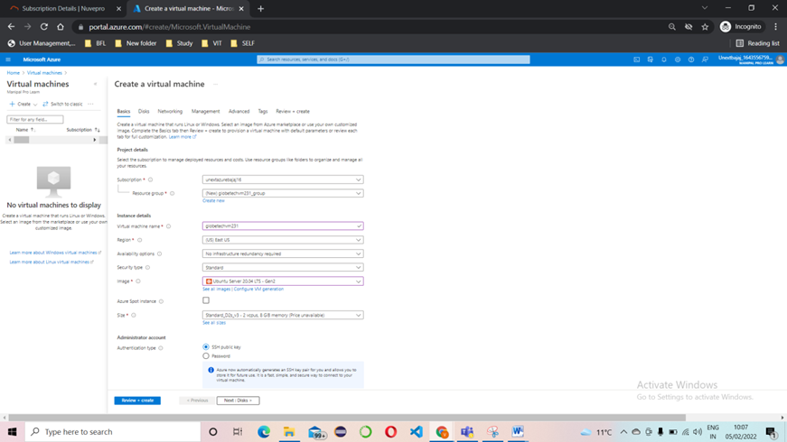

**Step2:** Review and create for validation

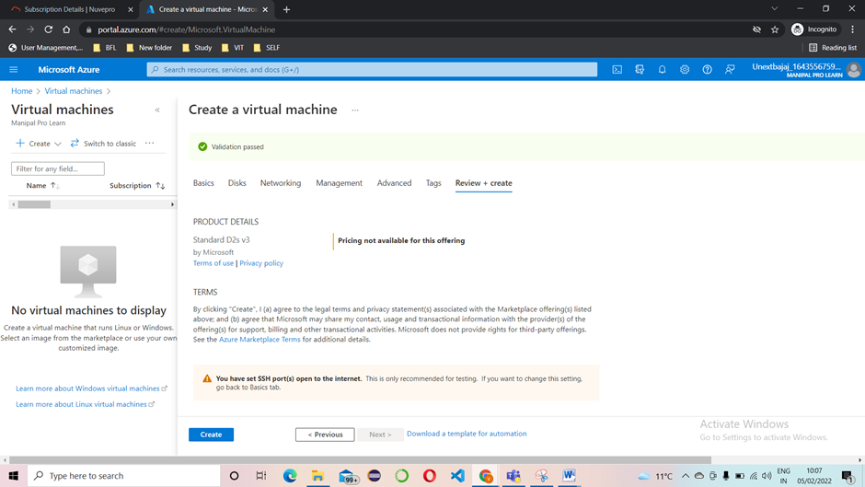

**Step3:** Validation is complete click on create

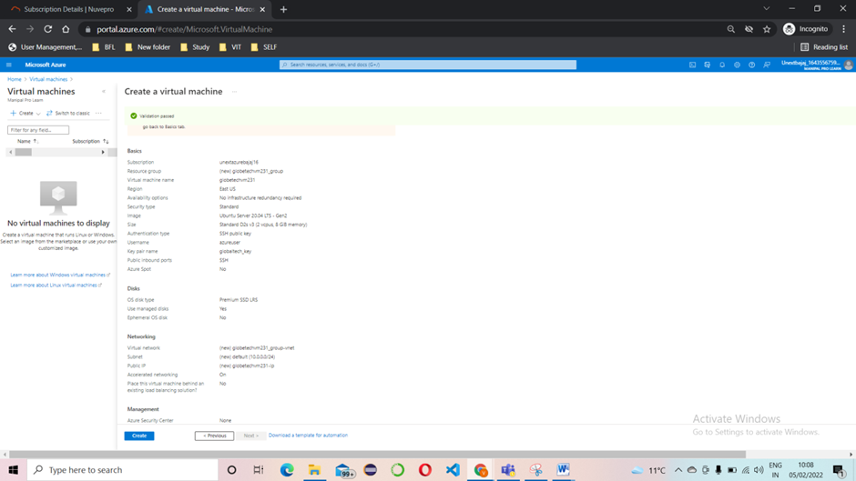

**Step4:** Download private key

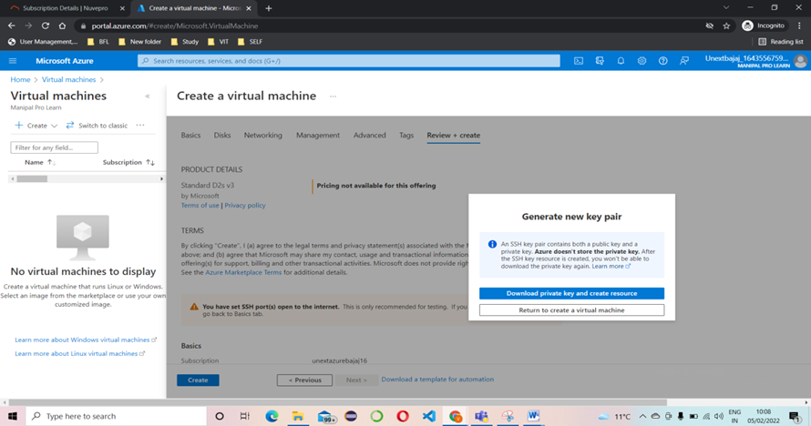

**Step5:** Go to resources.

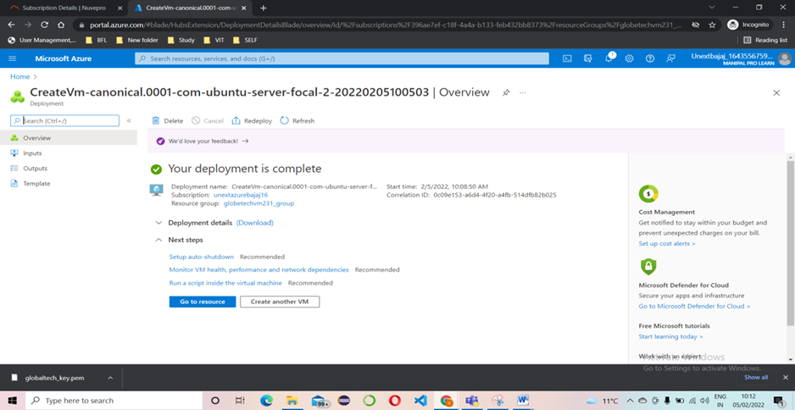

**Step6**: Copy the ssh key and run it on your cmd.

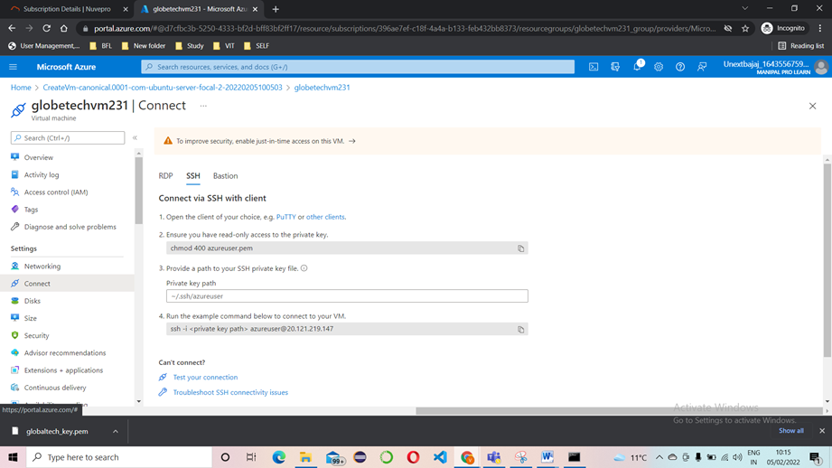

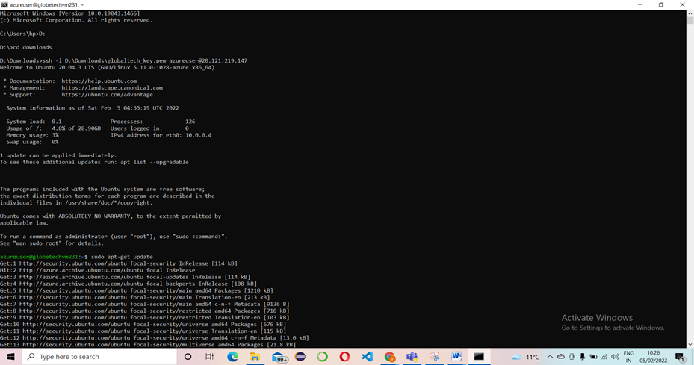

**Step7:** Install docker by updating sudo apt –get update and install by sudo apt install docker.io

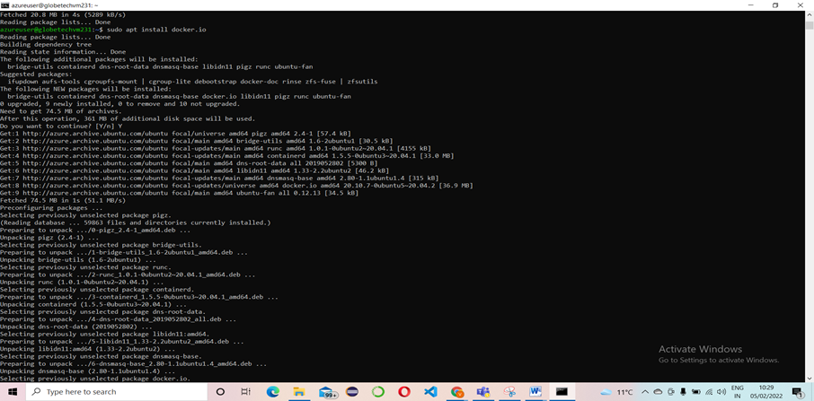

**Step8: Docker images**

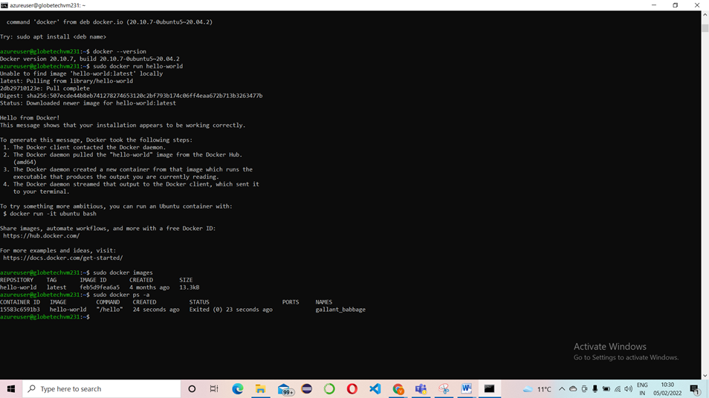

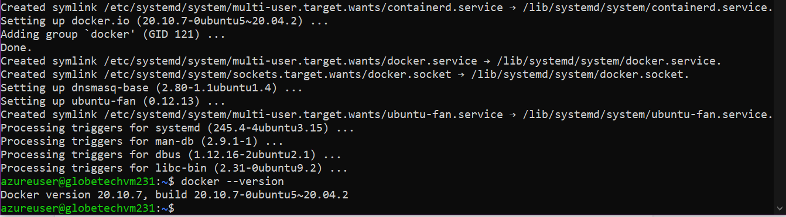

**Step9:** to create hello-world image we can using below command - sudo docker run hello-world

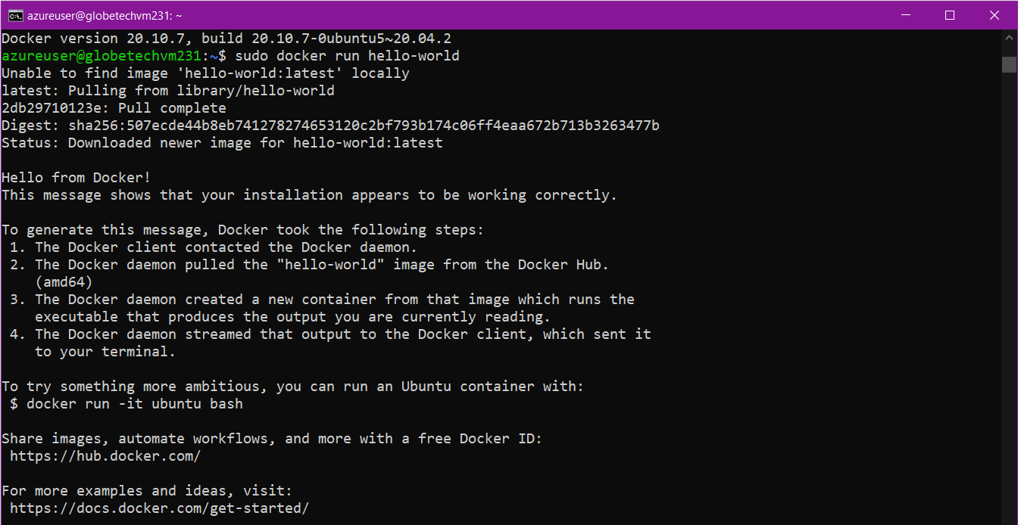

**Case2: Explain with screenshots - how docker images will be installed in a vm and explain various features of docker**

A Docker image is a read-only template that contains a set of instructions for creating a container that can run on the Docker platform. It provides a convenient way to package up applications and preconfigured server environments, which you can use for your own private use or share publicly with other Docker users.

Solution

To create docker images use the following command

>>>to create hello-world image we can using below command

Command>>sudo docker run hello-world



>>>to see how many images are present in docker by use by below command

Command>>sudo docker images



**Various features of docker-**

· Faster and easier configuration.

· Application isolation.

· Increase in productivity.

· Swarm. · Services.

· Routing Mesh.

· Security Management.

· Rapid scaling of Systems.

**Case 3. In Azure - please create kubernetes cluster called: Bajajkubecluster678 & Create a sample Voting app & explain all steps with screenshots.**

**Step1:** Create a kubernetes cluster

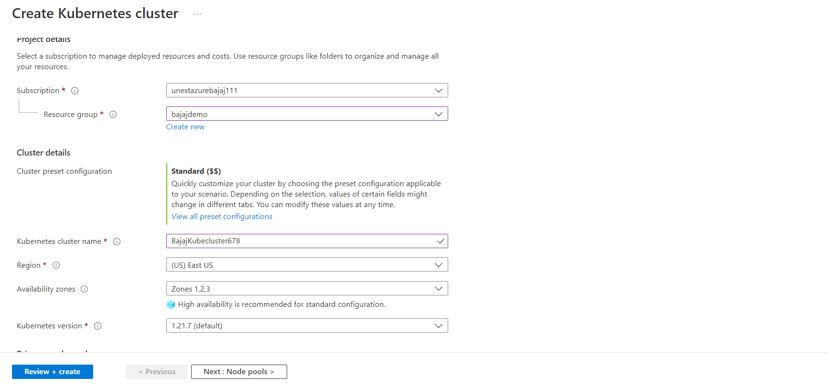

**Step2:** Validation

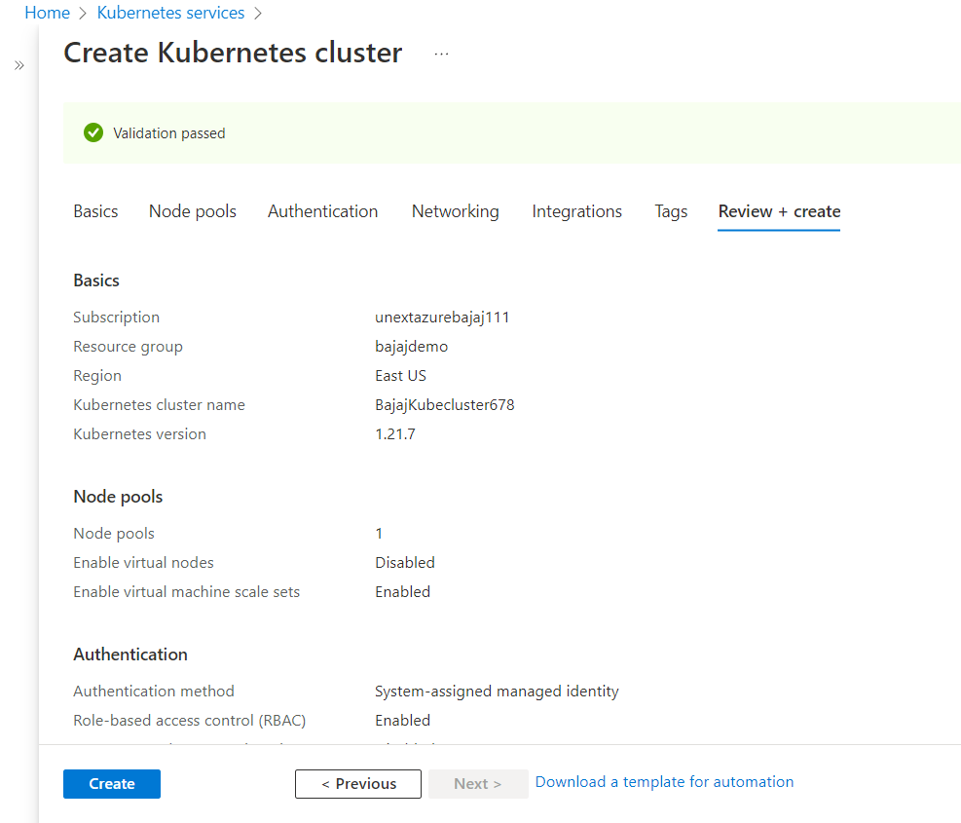

**Step3:** Configure kubectl to connect to your Kubernetes cluster using the [az aks get-credentials](https://docs.microsoft.com/en-us/cli/azure/aks#az_aks_get_credentials) command.

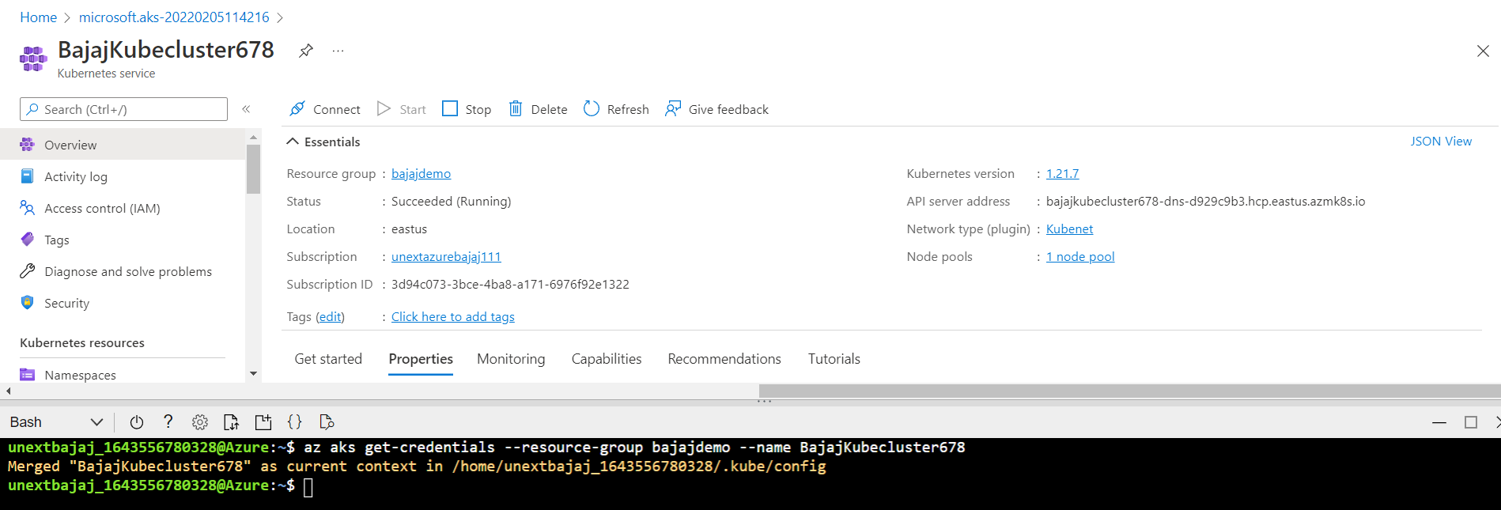

**Step4:** Verify the connection to your cluster using kubectl get to return a list of the cluster nodes

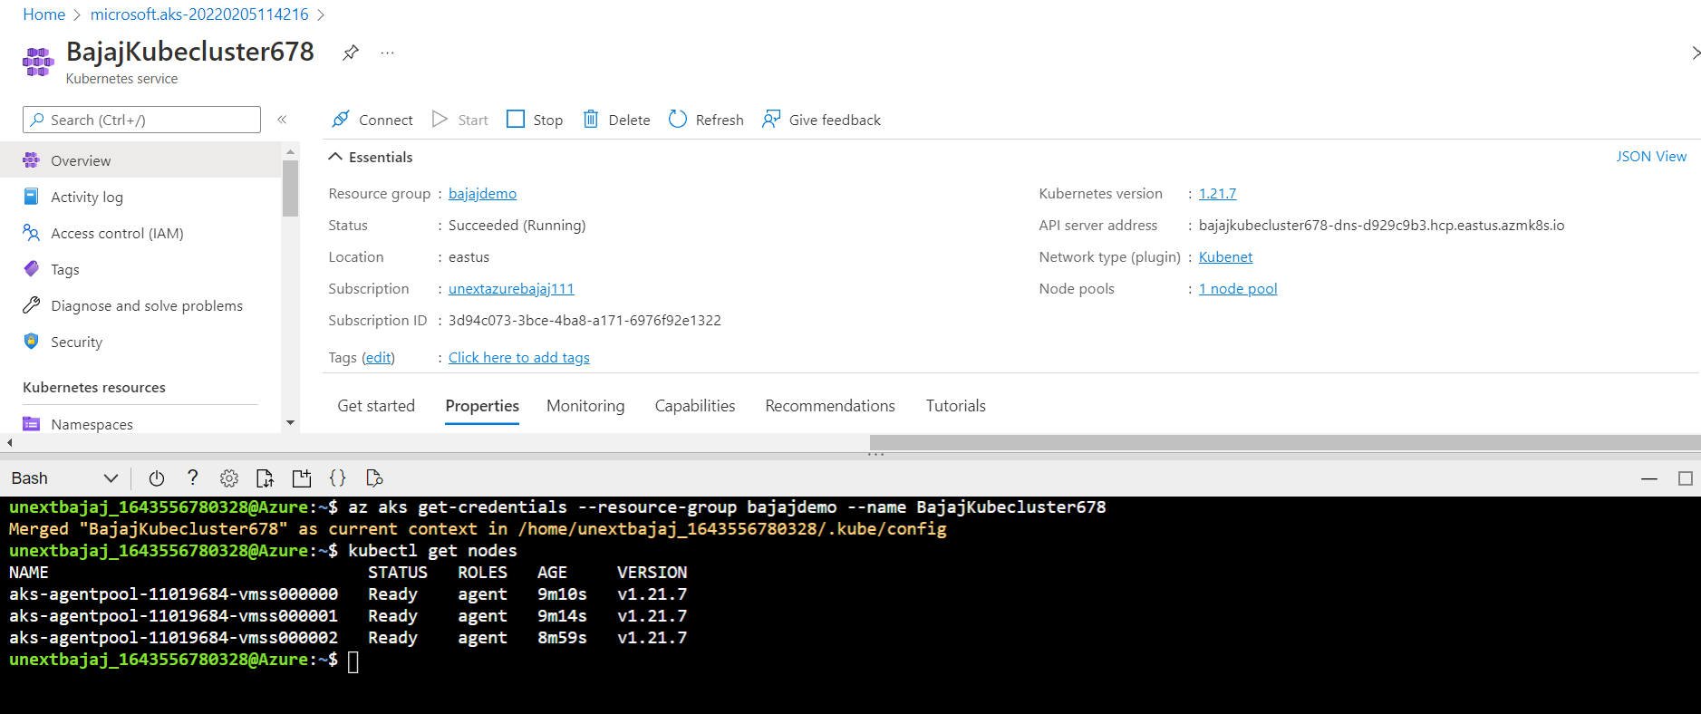

**Step5:** Create application in cloud shell use an editor to create a file named azure-vote.yaml

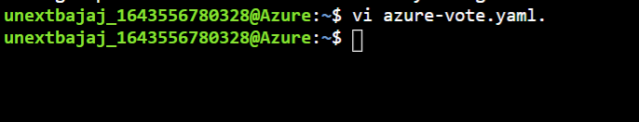

**Step6:** Deploy the application using the kubectl apply command and specify the name of your YAML manifest

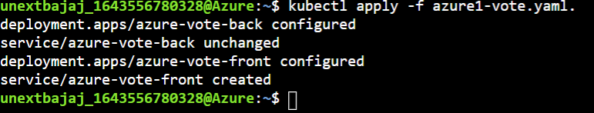

**Step7:** Now test the application



**Step8:** Run the application using external-ip

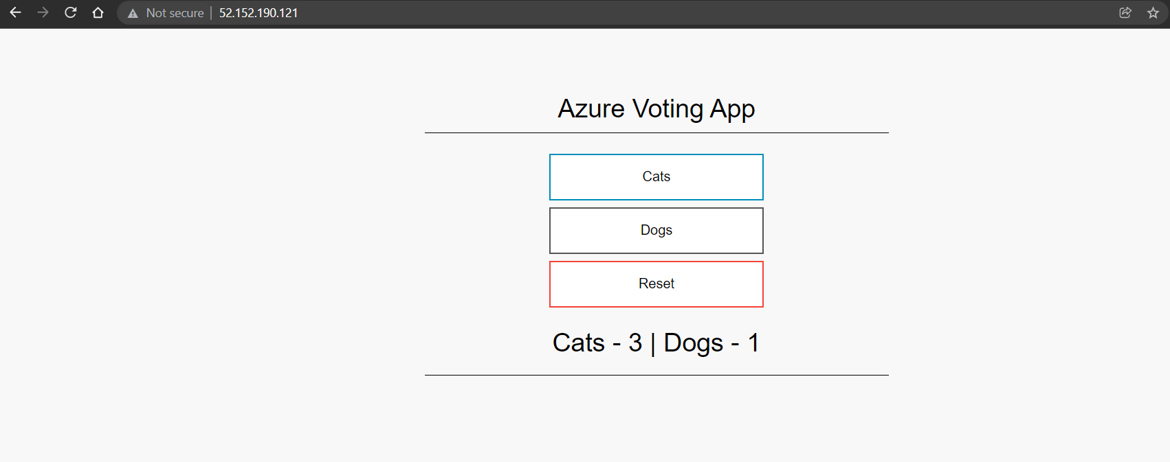

**Case 5. Explain various cloud Service & deployment models with block diagrams & examples**

The cloud service models describe to what extent your resources are managed by yourself or by your cloud service providers.

The offers are mainly categorized into the following service models:

1. **On-premises**: On-premises describes a model in which the user manages all resources alone.
2. **Infrastructure as a Service (IaaS)**: IaaS describes a model in which the cloud provider gives the consumer the ability to create and configure resources from the computing layer upwards. This includes virtual machines, containers, networks, appliances, and many other infrastructure-related resources.
3. **Platform as a Service (PaaS)**: PaaS gives the consumer an environment from the operating system upwards. So the consumer is not responsible for the underlying infrastructure.
4. **Software as a Service (SaaS)**: SaaS is the model with the lowest levels of control and required management. A SaaS application is reachable from multiple clients and consumers, and the owning consumer doesn't have any control over the backend, except for application-related management tasks.

### **Cloud deployment models**

### Cloud deployment models describe the way in which resources are provided in the cloud.

1. A **private cloud** is an environment/infrastructure, built and operated by a single organization, which is only for internal use. The deployment model based on the on-premises service model is private cloud
2. A **public cloud** is an offer from a service provider (for example, Microsoft Azure), that can be accessed by the public. This includes individuals as well as companies. The deployment model based on the IaaS and the PaaS service model is public cloud

**There a 3 types of cloud service models.** They are:

· **IaaS**: It provides virtualized computing resources over the internet. No worries about the underlying physical machine. Abstract the user from the physical machine.

· **PaaS**: No control over the underlying architecture including OS, storage, servers, etc. The Cloud Provider gives the ability to the customer to deploy customer created apps using programming languages, tools etc that are provided by the Cloud Provider.

· **SaaS**: Cloud Provider leases applications or softwares are owned by them to its client. Example: Salesforce provides CRM (Customer Relation Manager)

Deployment models

**There are 3 types of cloud deployment models.** They are:

**· Public Cloud:** A service provider makes resources, such as applications and storage available to the general public over the internet. Easy and inexpensive set-up because hardware, application and bandwidth costs are covered by the provider. No resources are wasted because we have to pay for what we use.

**· Private Cloud:** Offers hosted services to a limited number of people behind firewall, so it minimizes the security concerns. Private cloud gives companies direct control over their data.

**· Hybrid Cloud:** A cloud computing environment which uses a mix of on-premises, private cloud and third-party, public cloud services. It helps us to leverage best of both worlds.

**Case 6- Explain what is cloud security & how virtualization is achieved with block diagram?**

There are many advantages of virtualization in cloud security.

· It ensures to make backup servers and maintain them so that in case of any natural disasters or any situation when a particular server goes down, we can switch to other servers and make use of them.

· Moreover, it helps us to set IAM polices, firewall policies to monitor and maintain who has the access to particular resources and what can they do with it.

· It helps in monitoring the servers and notifies us in case of any suspicious activities like if a hacker is trying to attack or someone from inside is transferring insider information to outside which could cause loss.

· There is CSA (Cloud Security Alliance) which looks after cyber security issues so that there won’t be any possible cyber security attacks anywhere in the world.

Virtualization is the process of creating a software-based or virtual representation of something, such as virtual applications, servers, storage, and networks.

We achieve virtualization by using cloud computing and Virtual Machines (VM). They allow the operating system of physical server to run on a virtual layer. It also allows us to run multiple virtual machines on the same hardware. Each virtual machine has its own OS, ram, CPU, and I/O resources.

Advantages of virtualization:

· Flexibility

· Less hardware maintenance

· Saving space

· More cost-effective

**Case 7- In Azure please create Azure Blob & upload sample CSV, Excell, TXT files in it & explain all steps with screenshots?**

Problem:

With multiple storage tiers and automated lifecycle management, store massive amounts of infrequently or rarely accessed data in a cost-efficient way. Replace your tape archives with Blob storage and never worry about migrating across hardware generations.

Solution:

1. Create a data storage with unique name

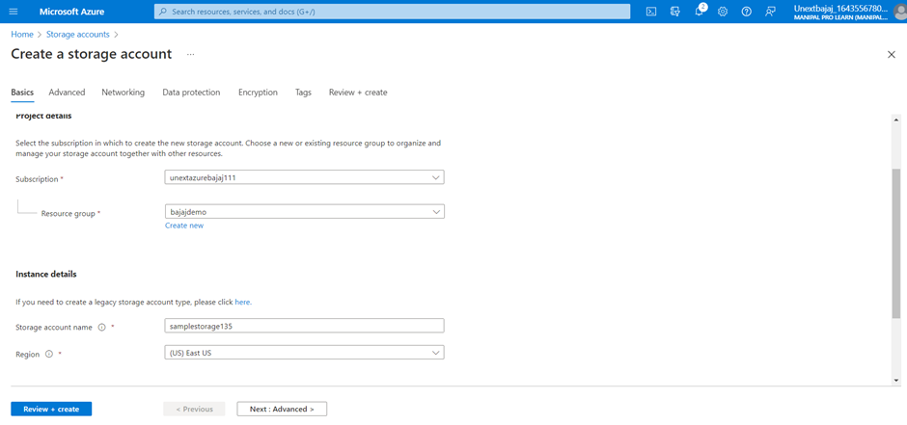

2. Create a container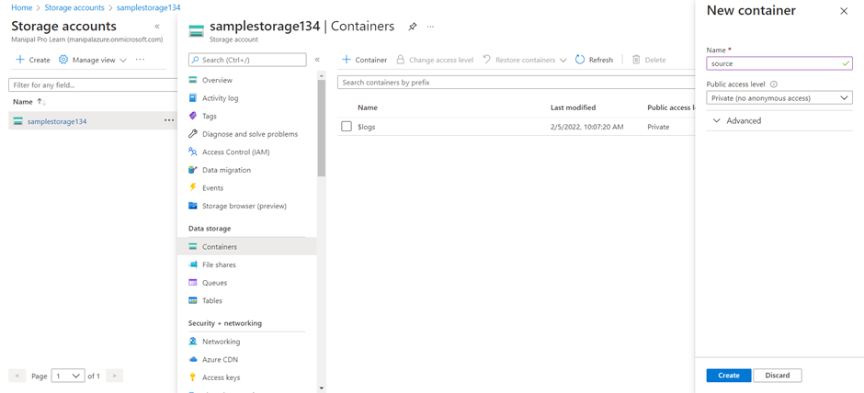

3. Create another container to receive the documents

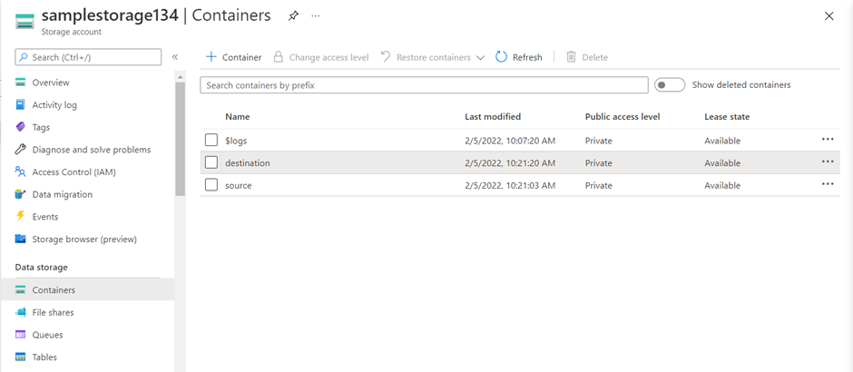

4. Create a data factory as a workplace to send and receive data

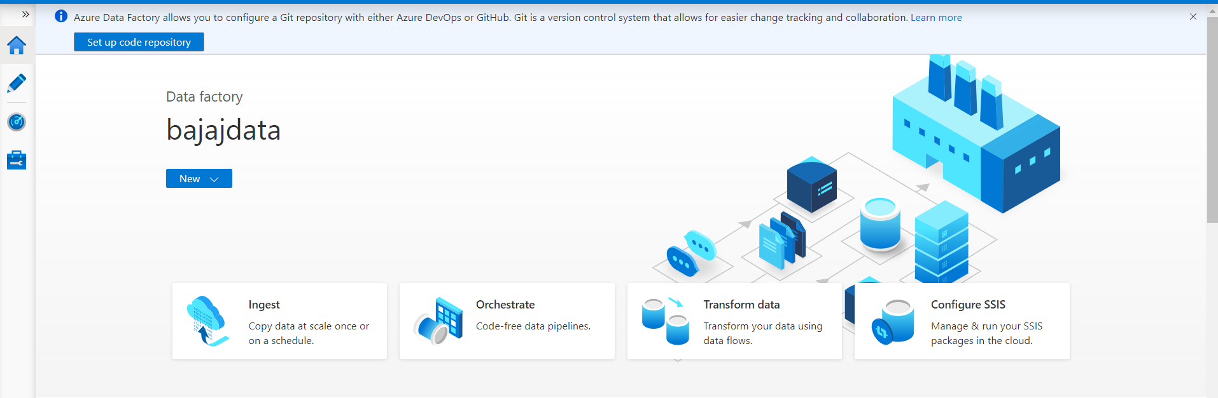

5. Click on ingest to create a blob

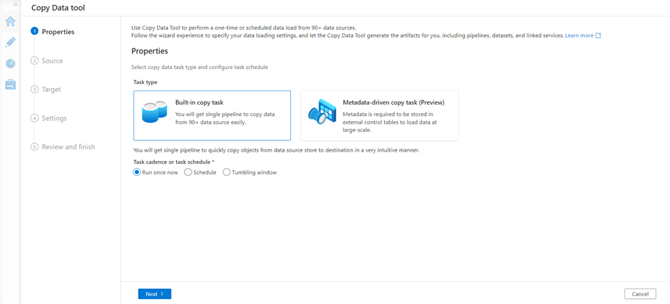

6. Create a new connection

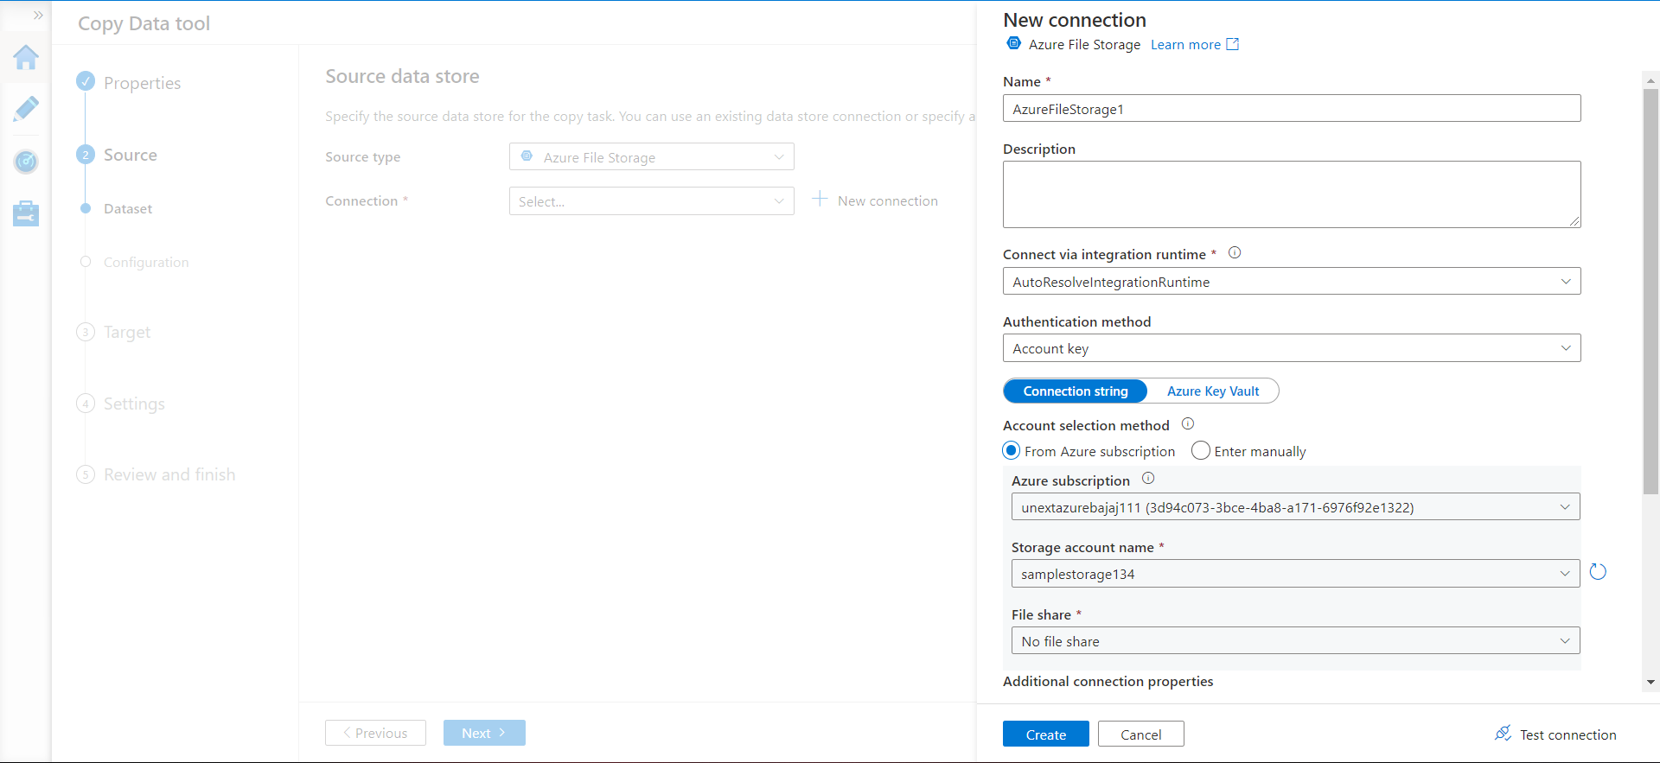

7. Test the new connection and add the folder path of source file

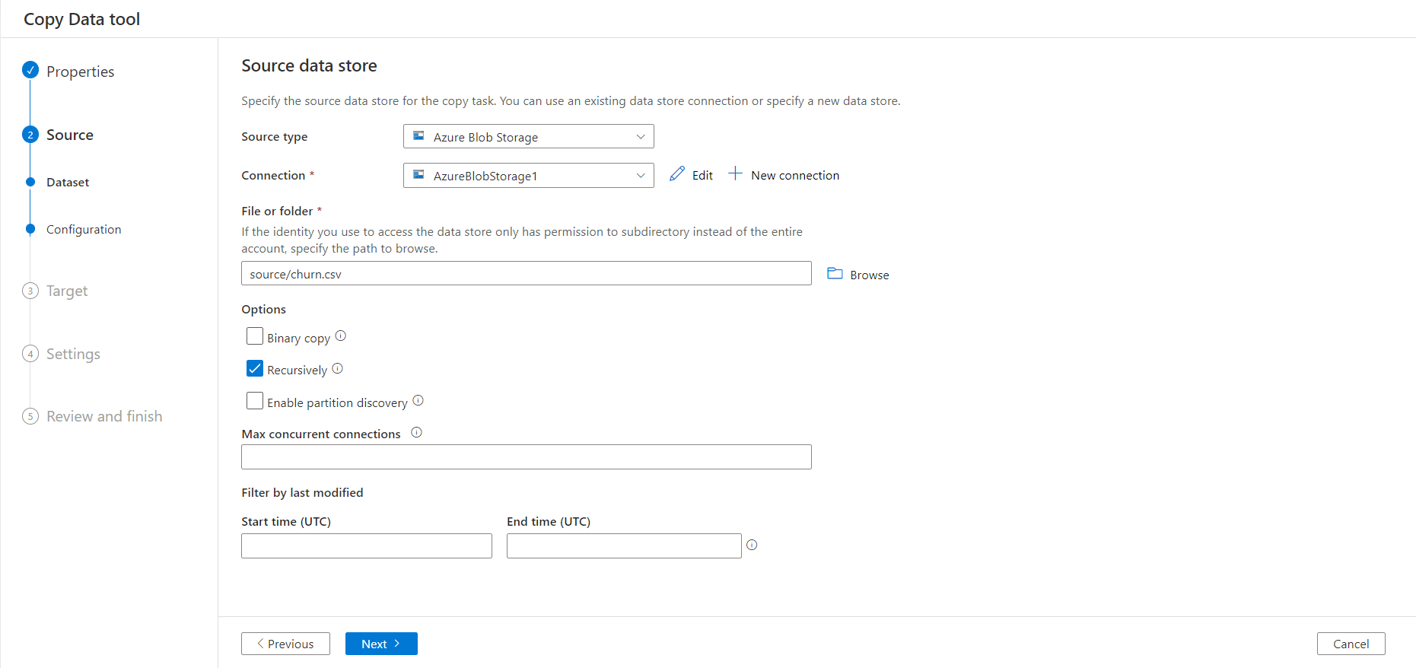

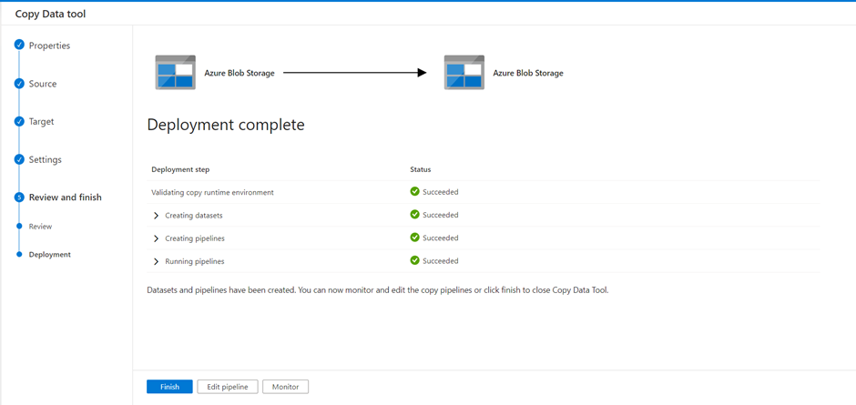8. Configure the delimiter

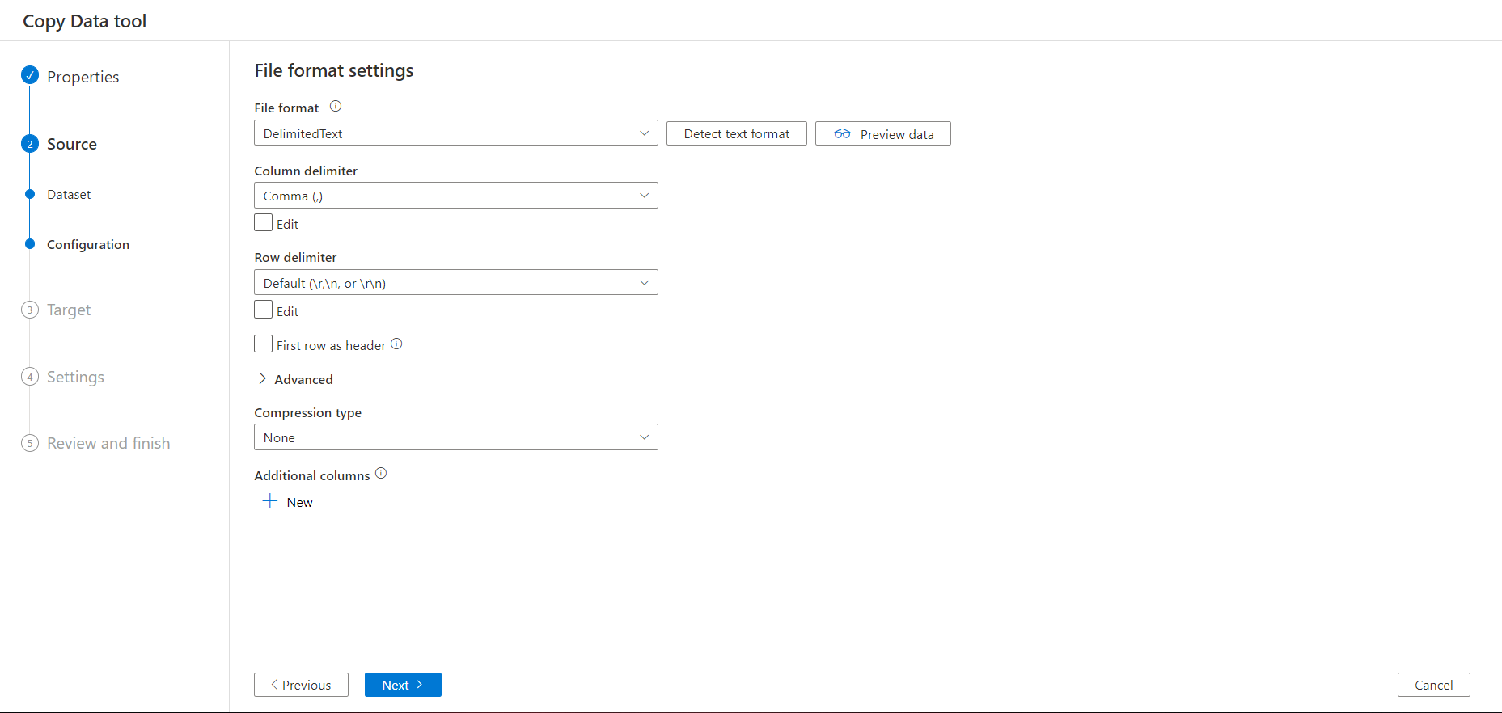

9. Confirm the settings

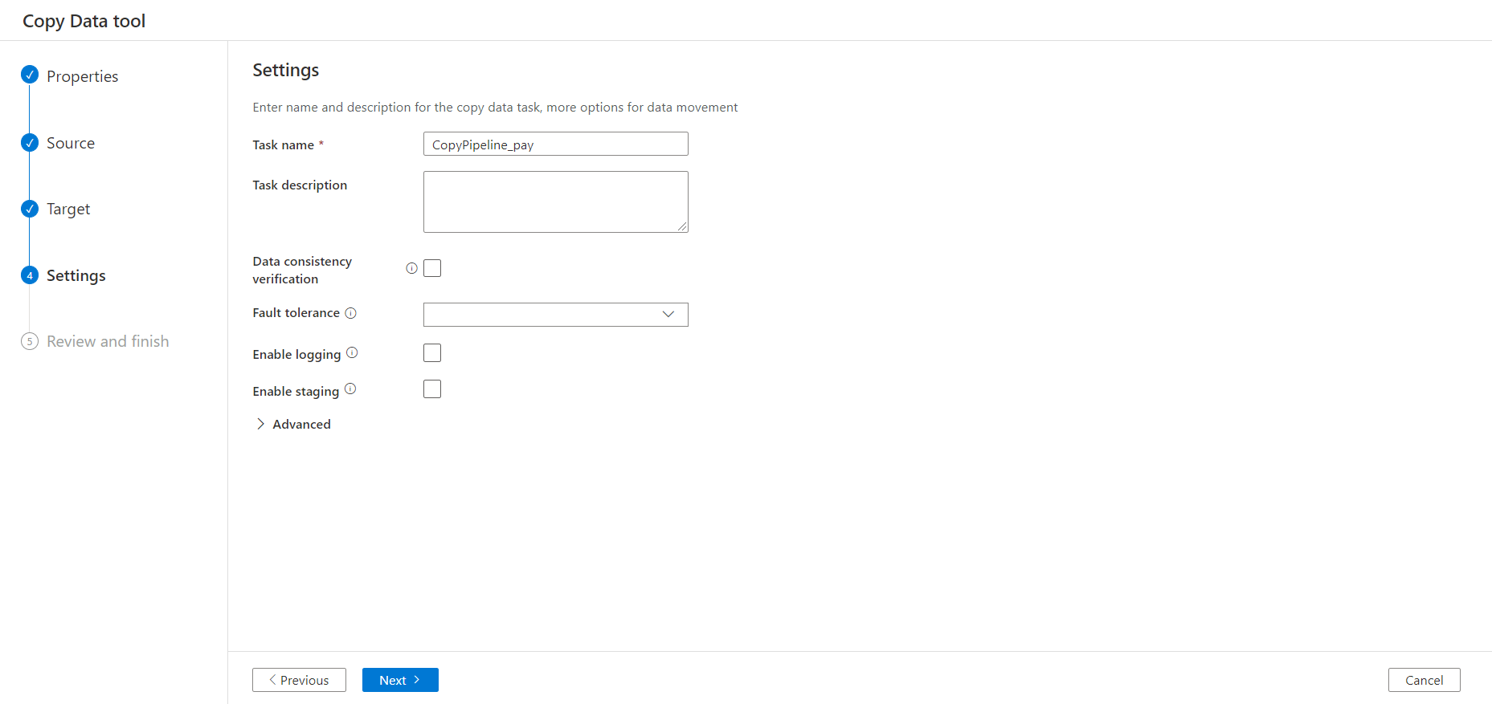

10. Validation



11. Check the file in destination folder

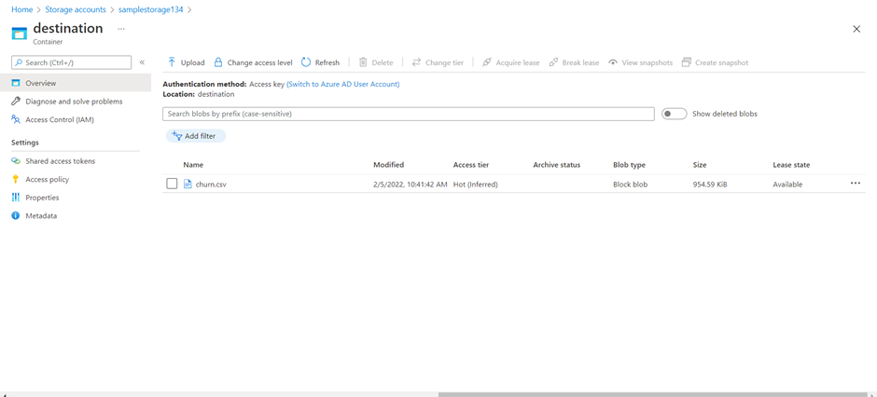

12. Follow the same steps for txt file

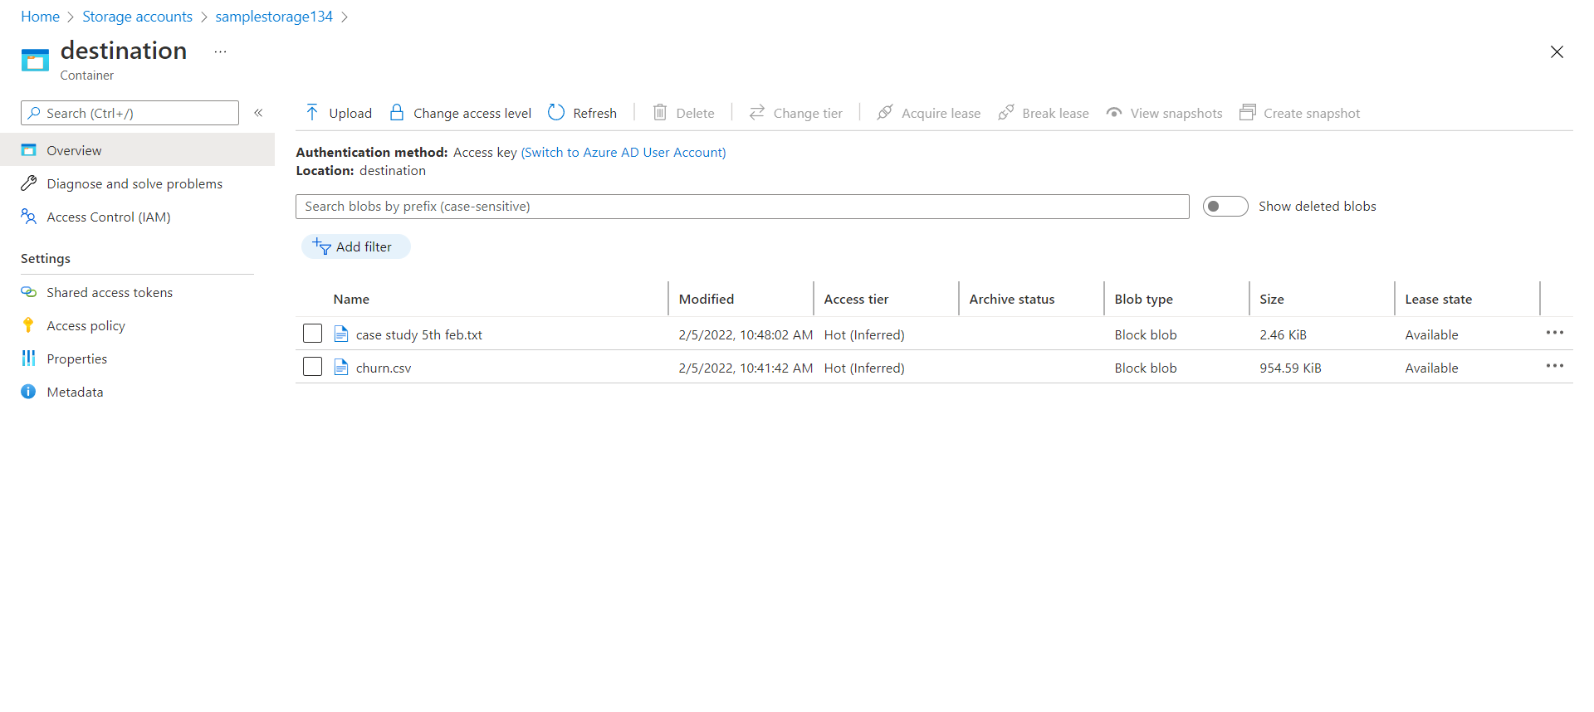

**Case-8- In azure please create Azure SQL Database & Create the table as Bajajsql123 & Run at least 15 SQL Queries explain all steps with screenshots?**

Step1- Search for SQL database in search tab of Microsoft Azure

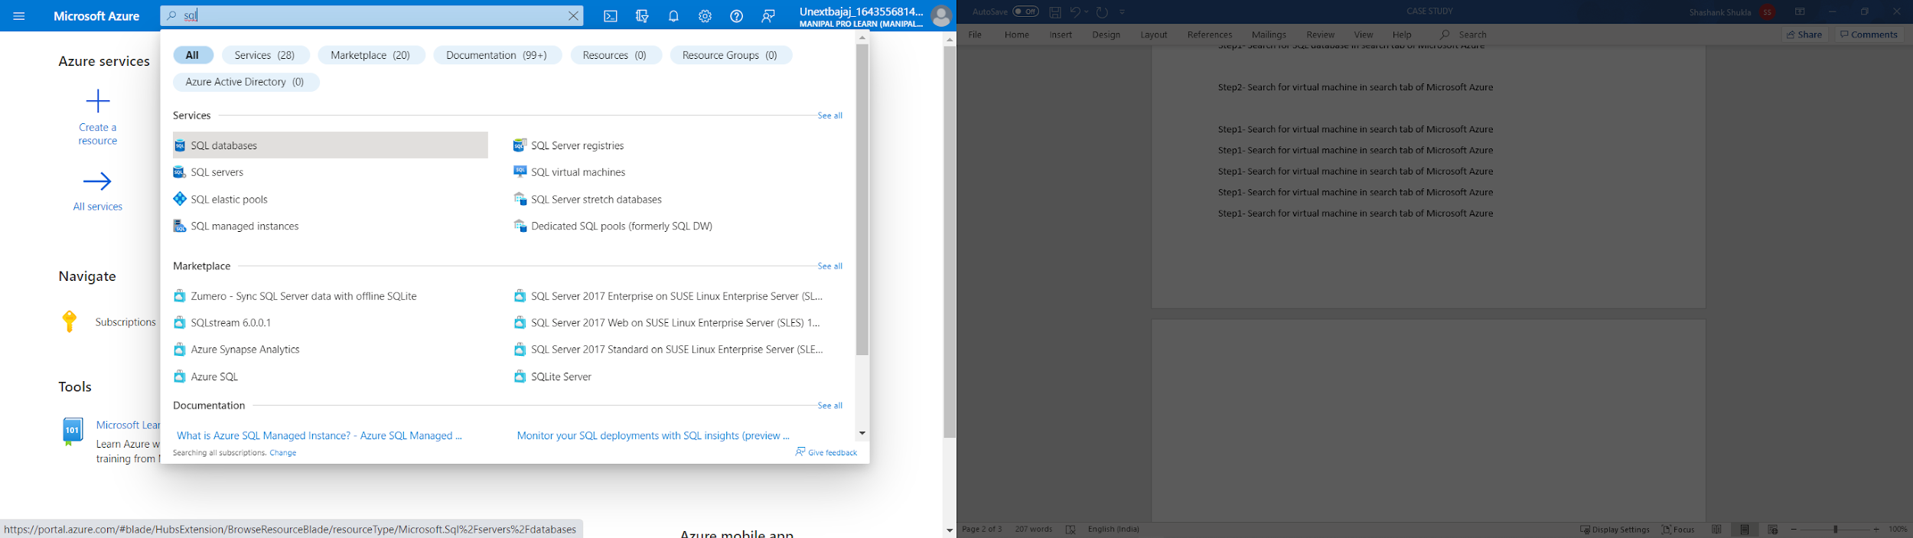

Step2- Click on Create in SQL Databases window

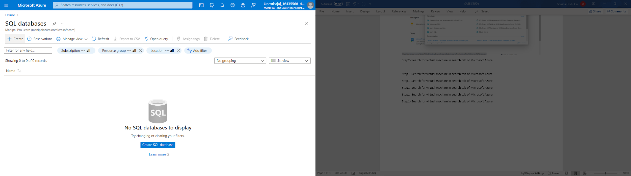

Step3- Set Resource group name by clicking on Create New and add new unique.

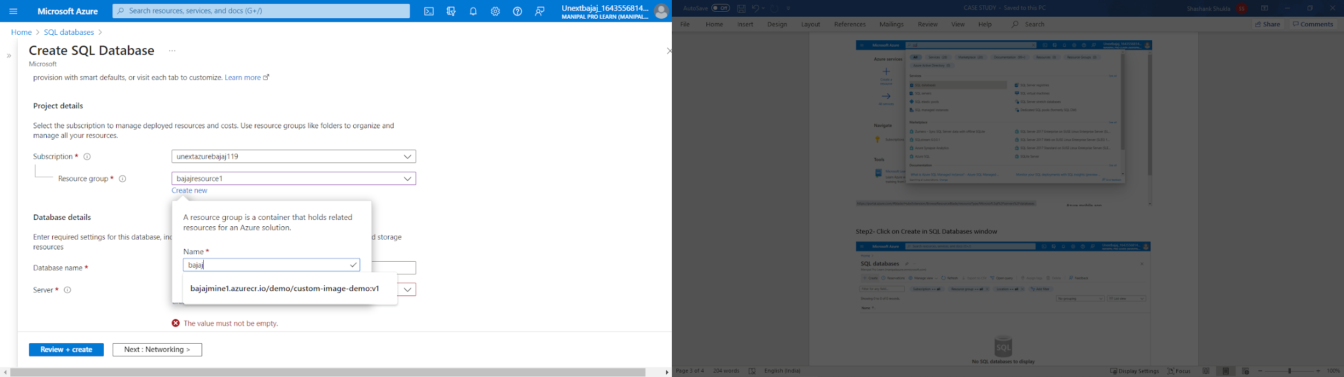

Step4- Create database name by clicking on Create name

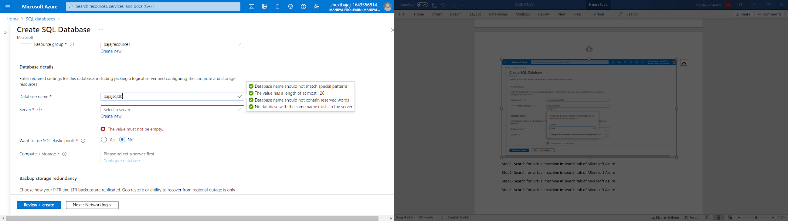

Step5- Click on create server to add server name

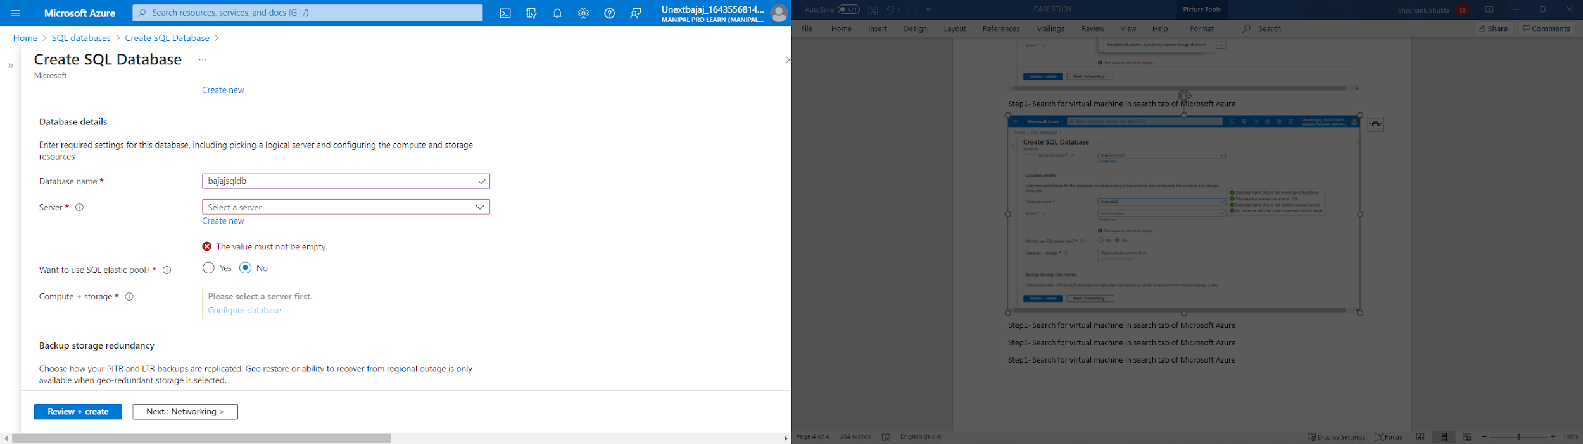

Step6- Add server name which is unique

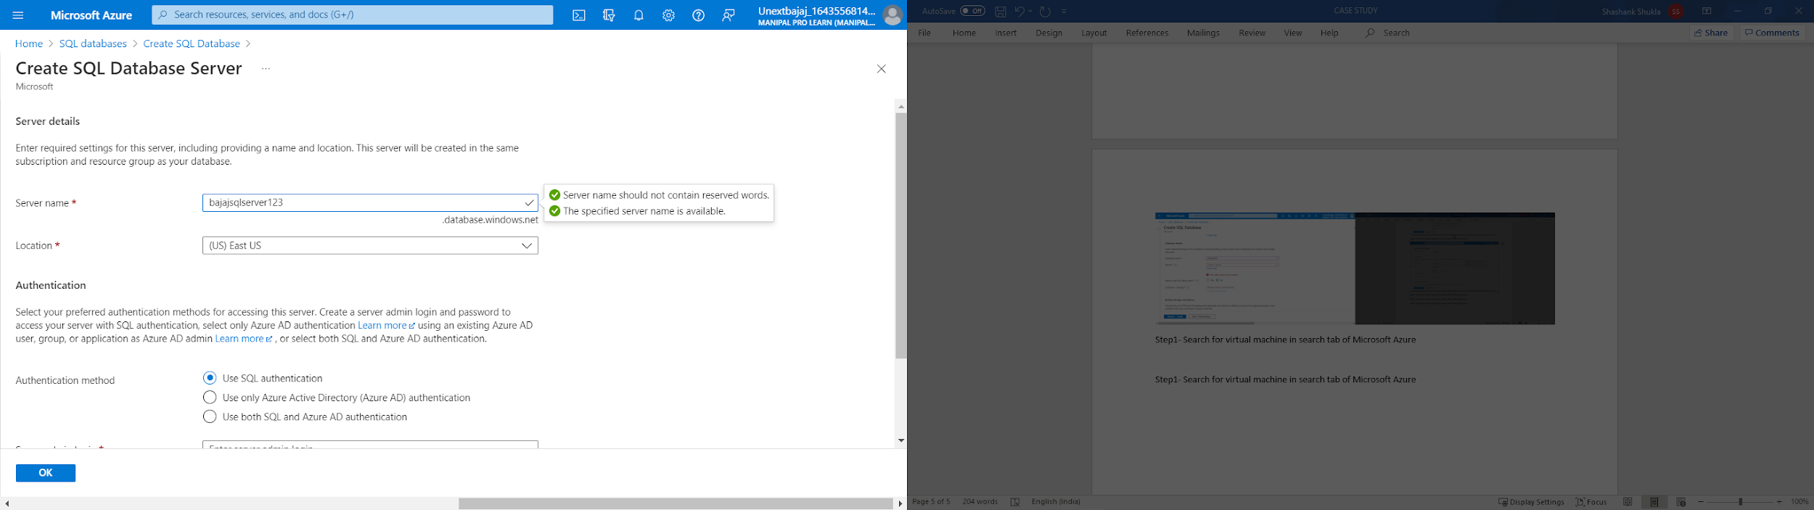

Step7- Add server admin login name and password

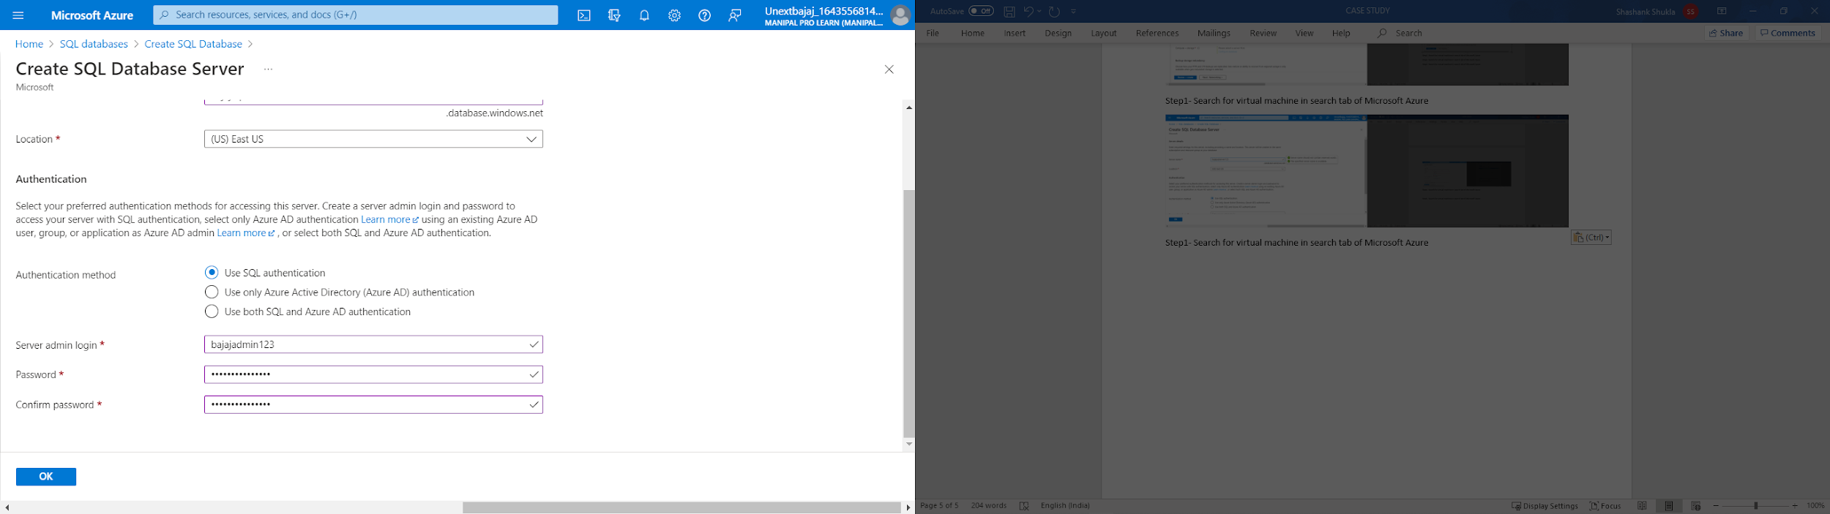

Step7- Add server admin login name and password

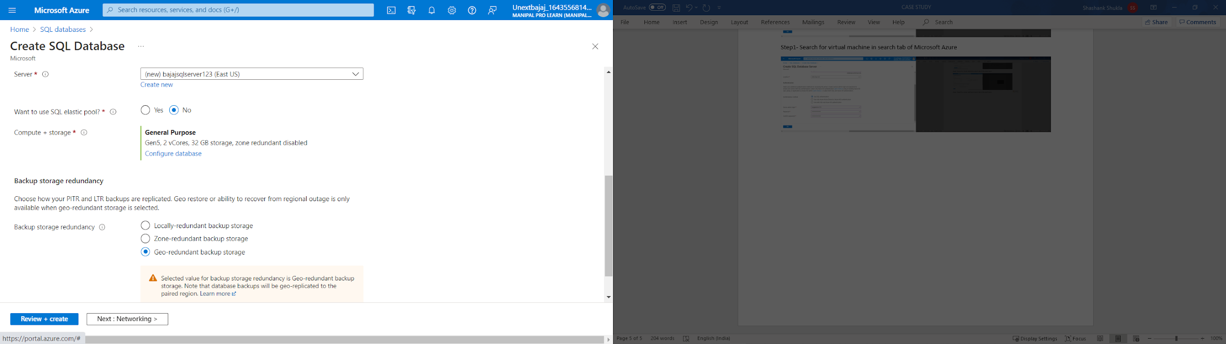

Step8- Click on Review + Create for validation

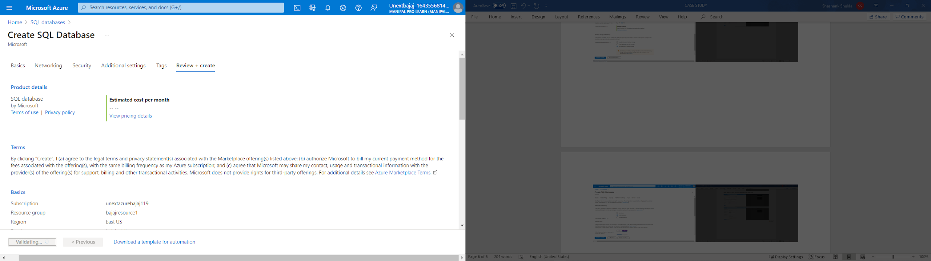

Step9- Click on Create for initializing deployment

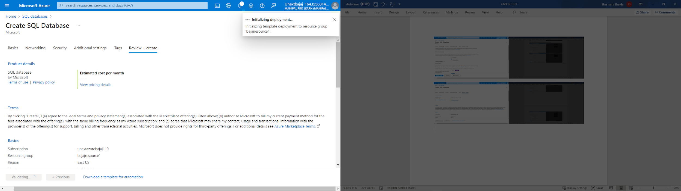

Step10- After deployment is create, click on Go to Resource

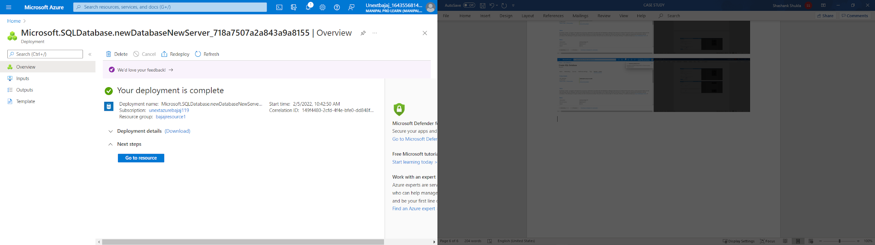

Step10- In the resource page, click on Query Editor

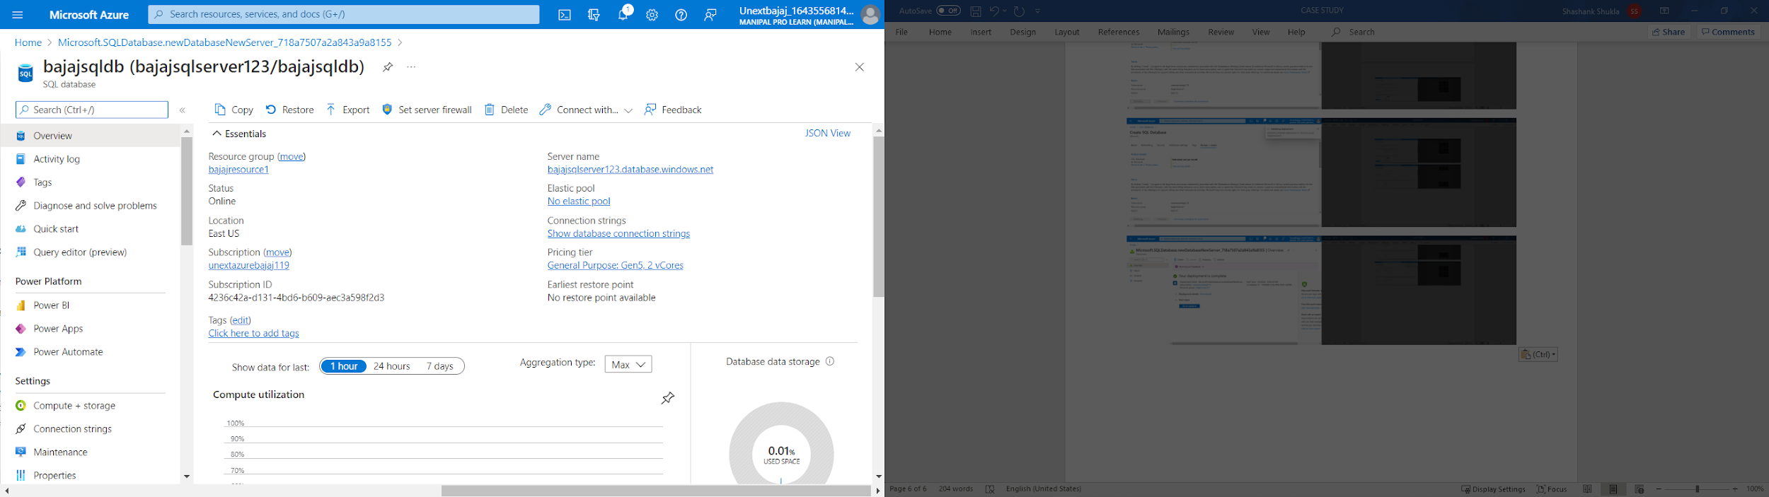

Step10- In the Query Editor, add password and click OK

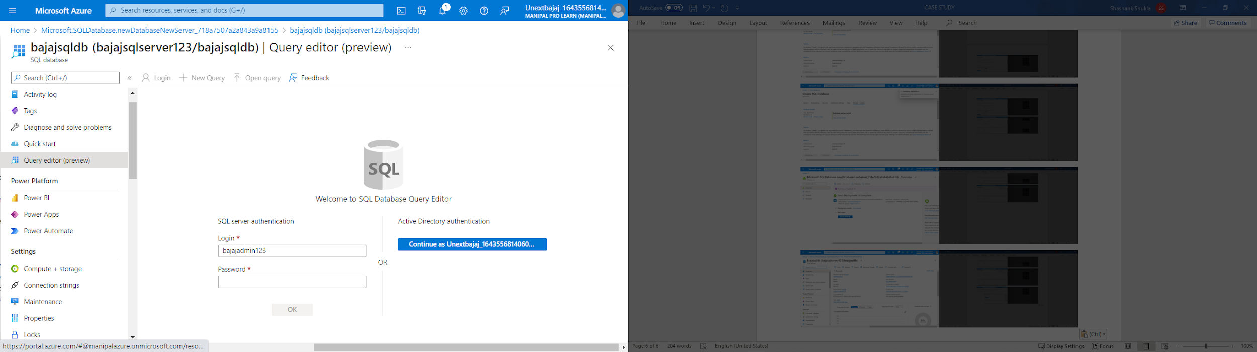

Step11- If the following error, click on Allowlist IP

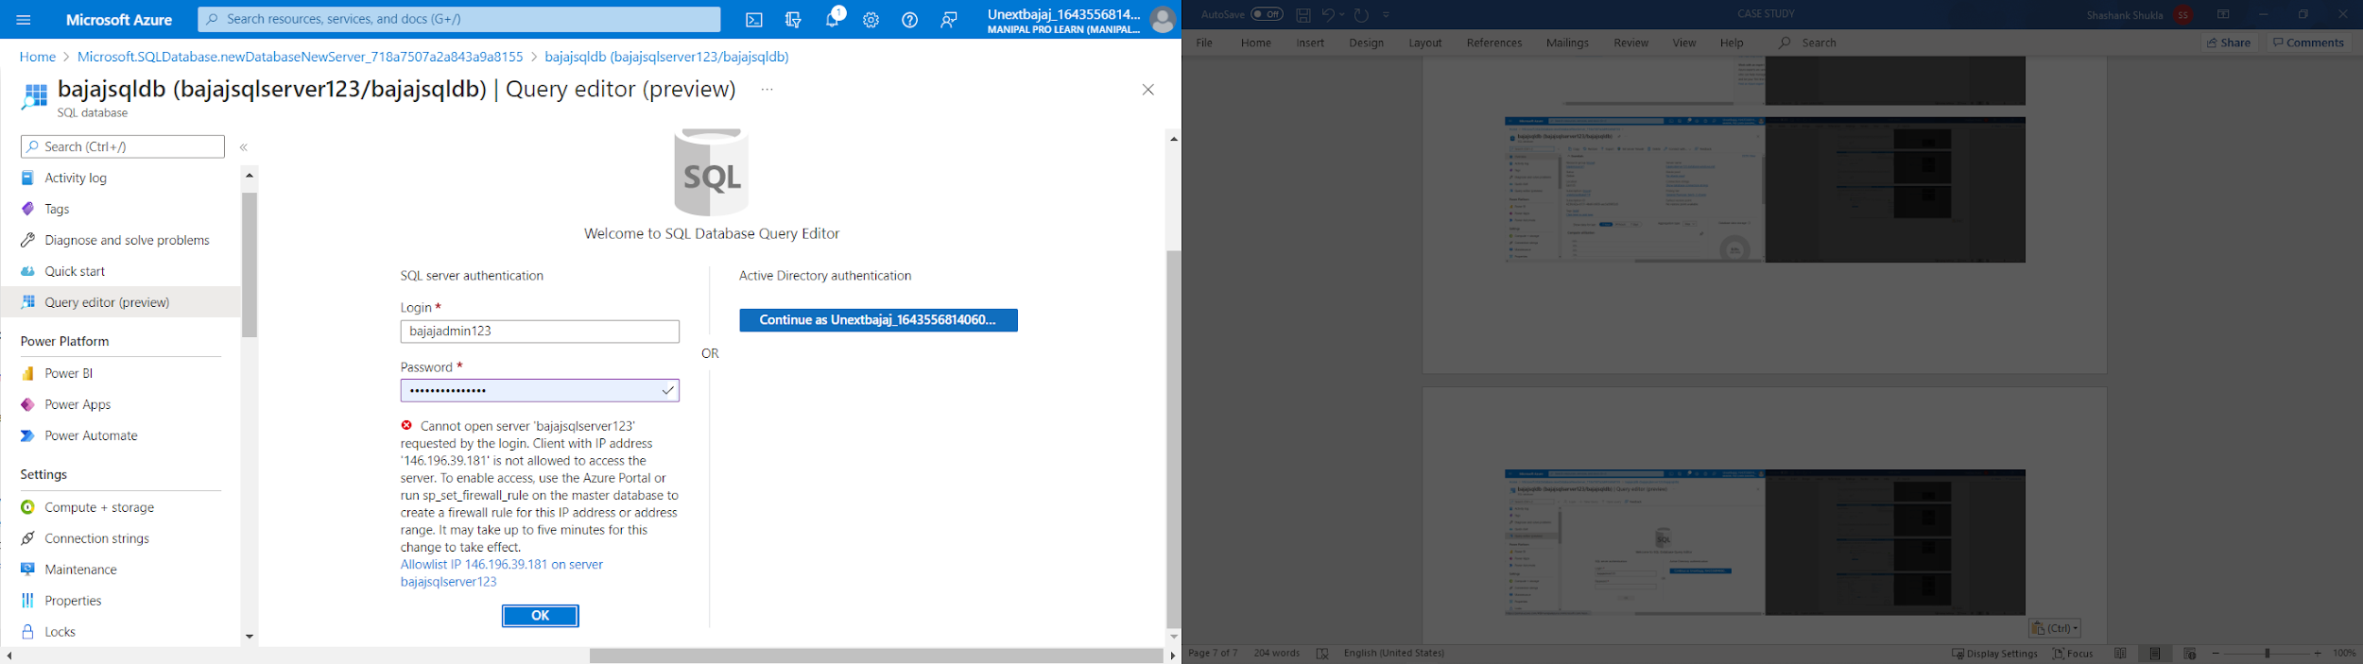

Step12- After it is successfully updated firewall, click on OK to enter into the database

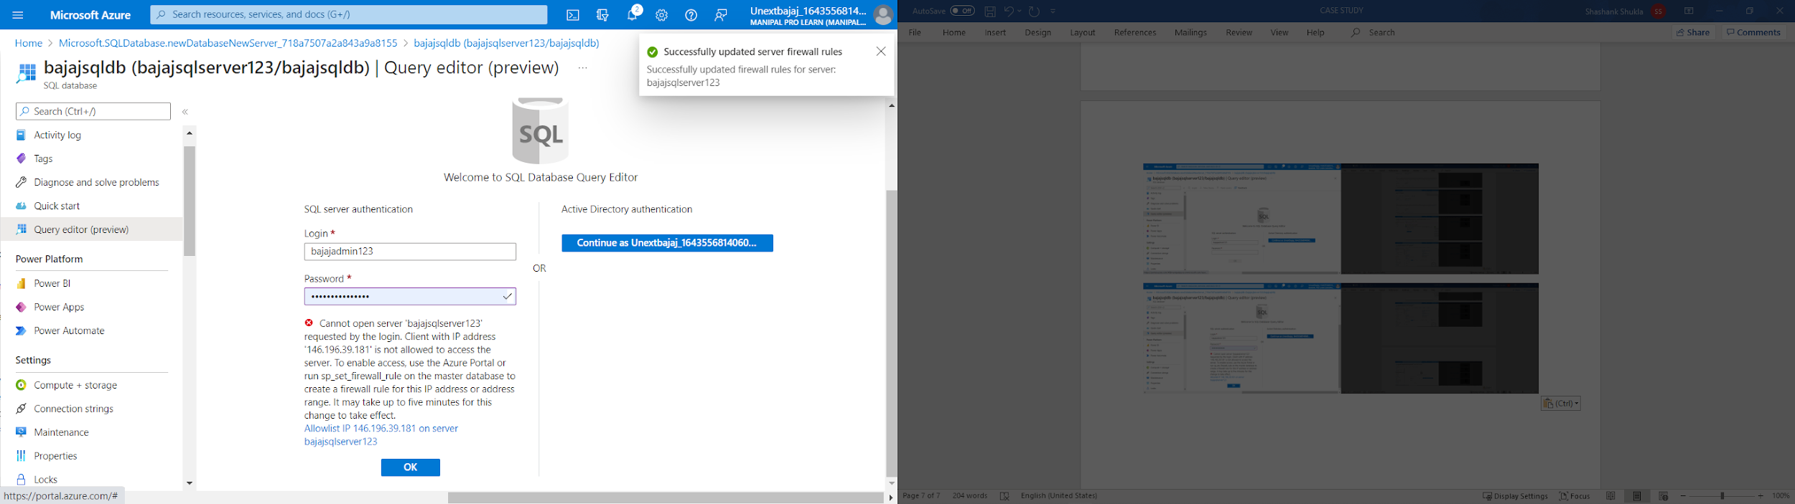

Step13- In the Query Editor page, run different queries

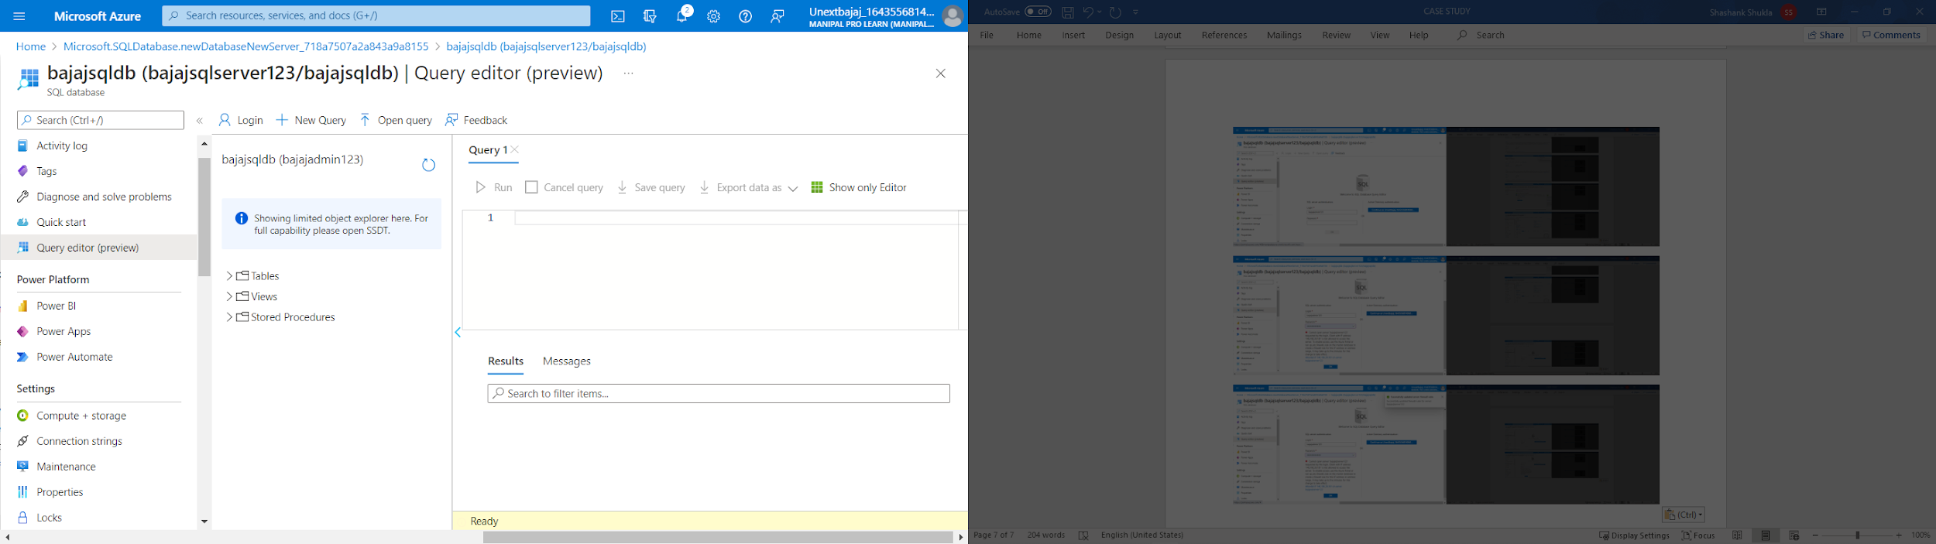

Step14- In the Query Editor, run the Create table query

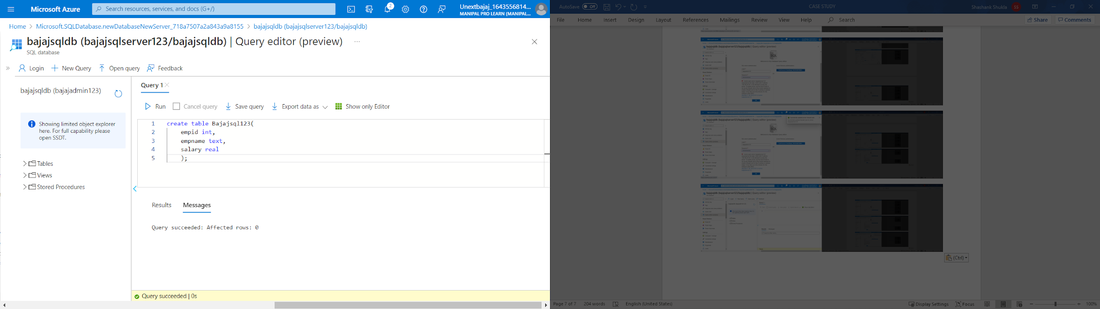

Step15- In the Query Editor, run the insert data into the table query

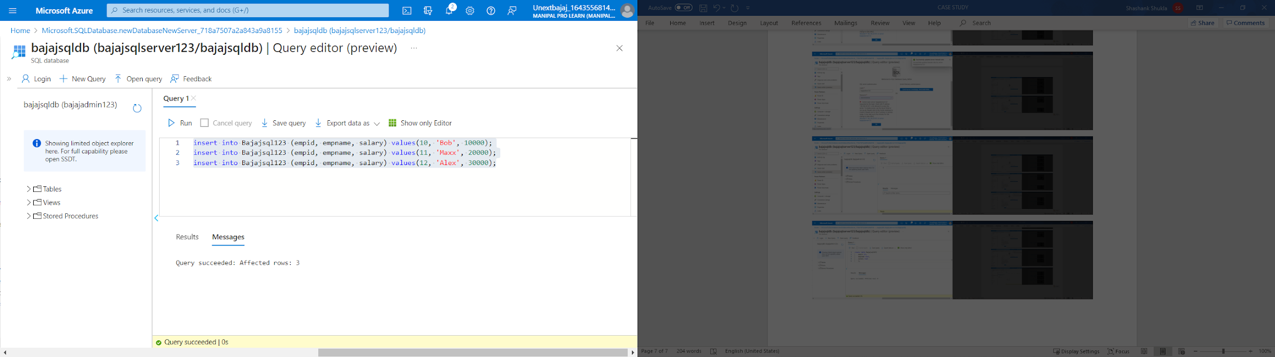

Step16- In the Query Editor, run the select all table query

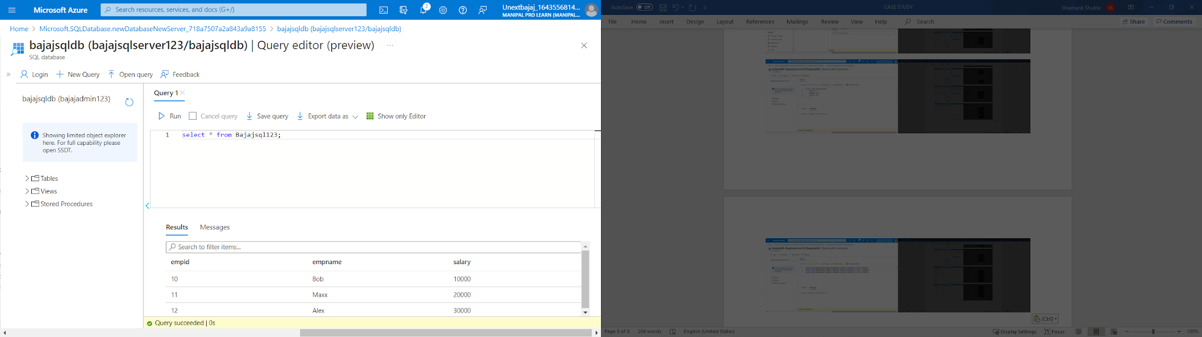

Step18- In the Query Editor, run the Alter table query

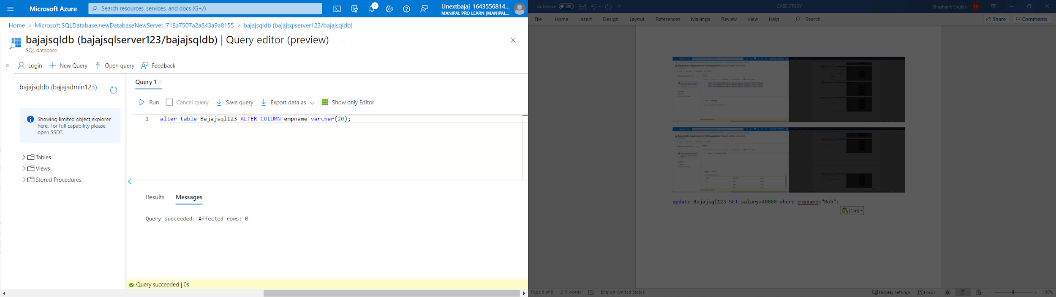

Step19- In the Query Editor, run the Update column table query

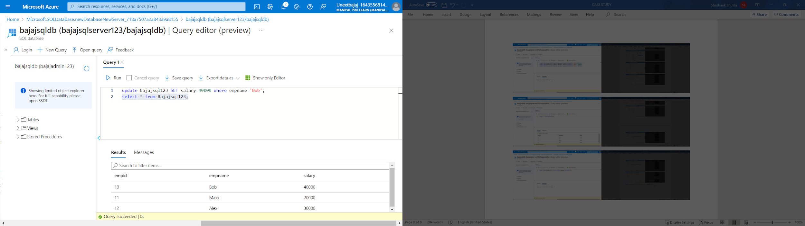

Step20- In the Query Editor, run the delete table query

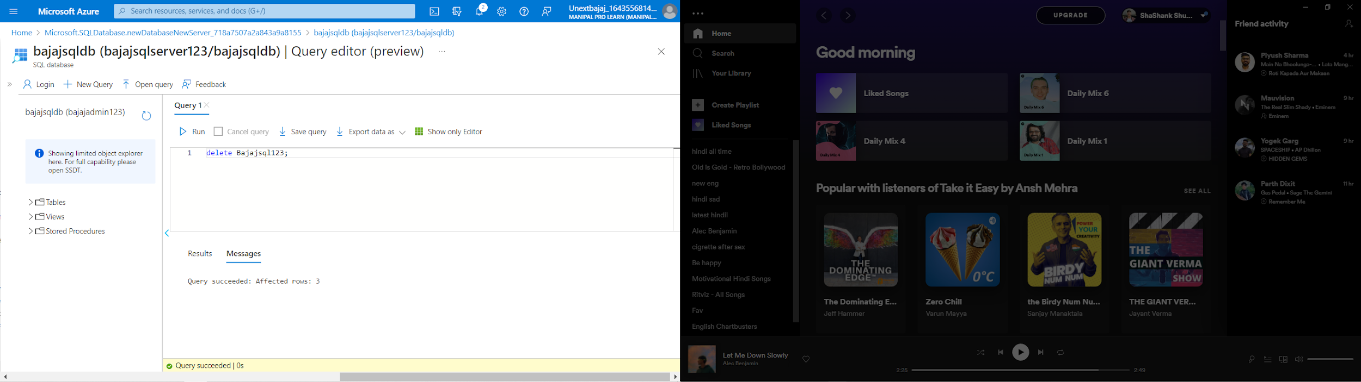

**Case-9- In Azure please create Azure Data factory, create source & destination storage blobs, try to copy a few files from Source blob to destination blob using Azure Data factory.**

Step1- Search for Storage accounts in search tab of Microsoft Azure

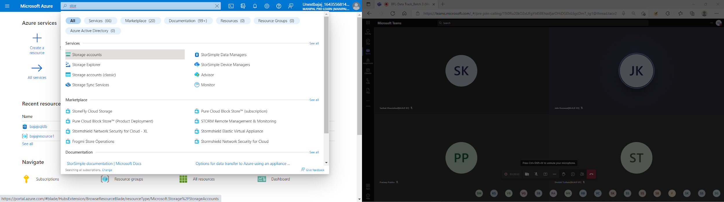

Step2- Click on create in Storage accounts

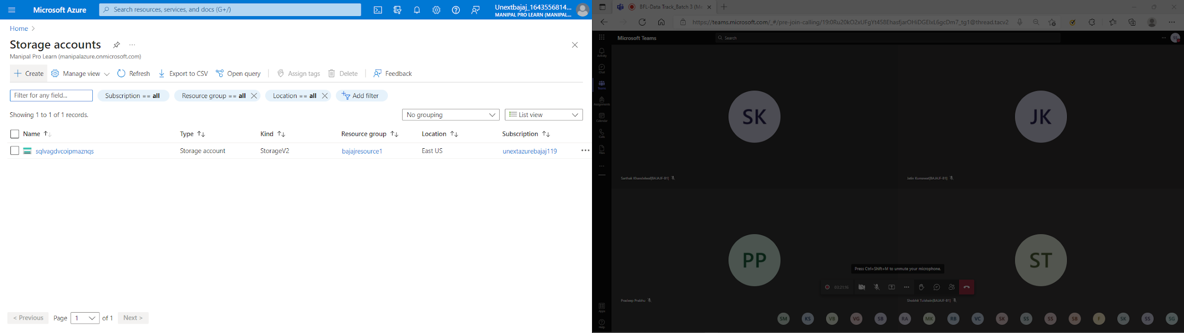

Step3- Add a new resource group name or select already existing resource group

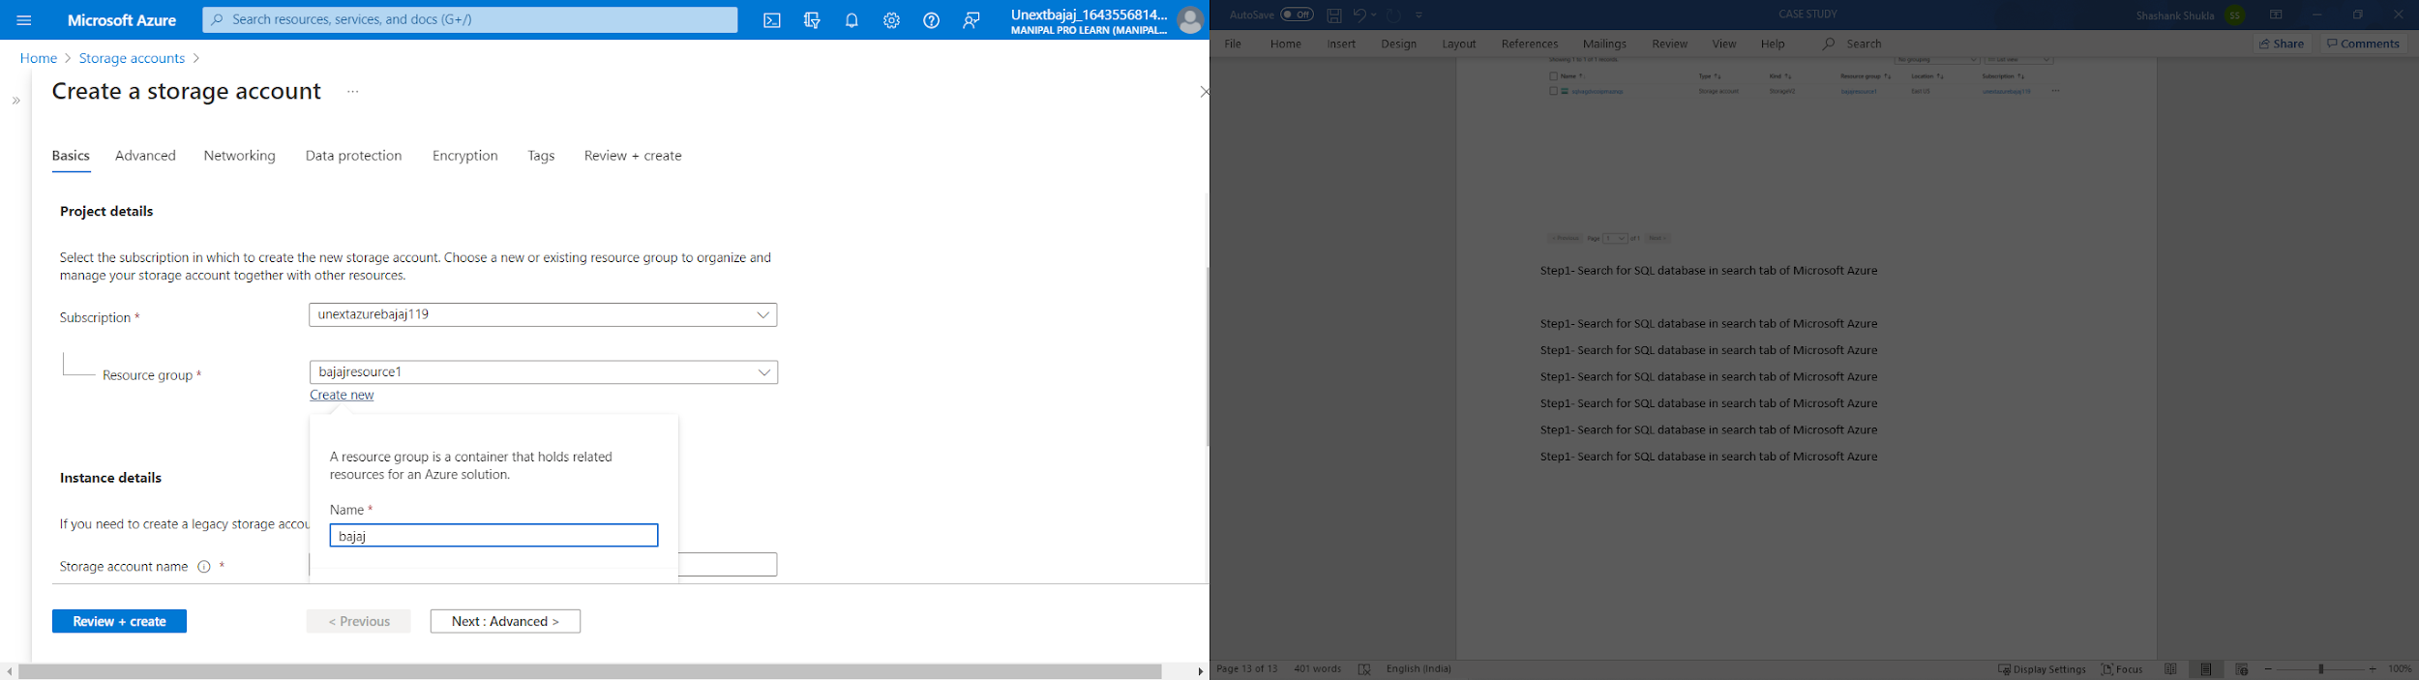

Step4- Enter any name for storage account name

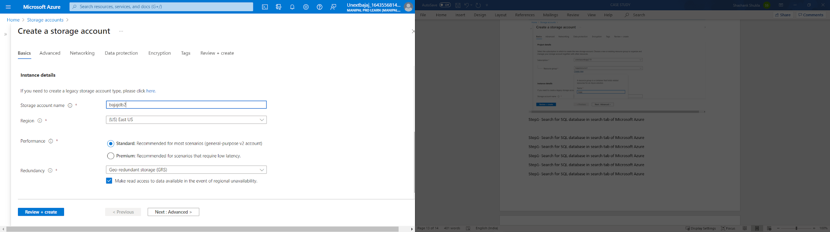

Step5- Click on Review + Create for validation

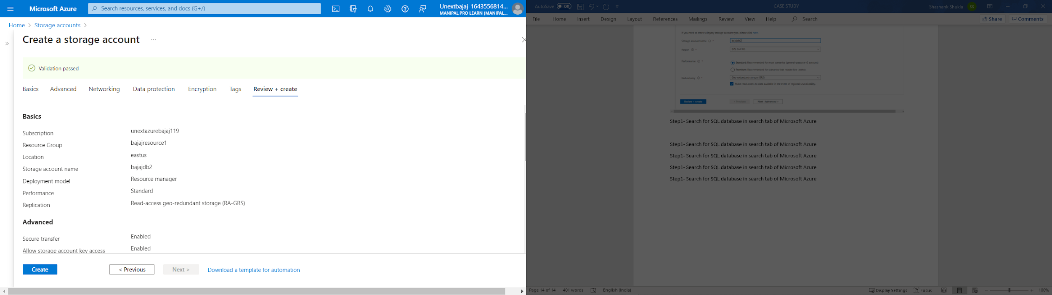

Step6- After validation is passed, click on create for initializing deployment

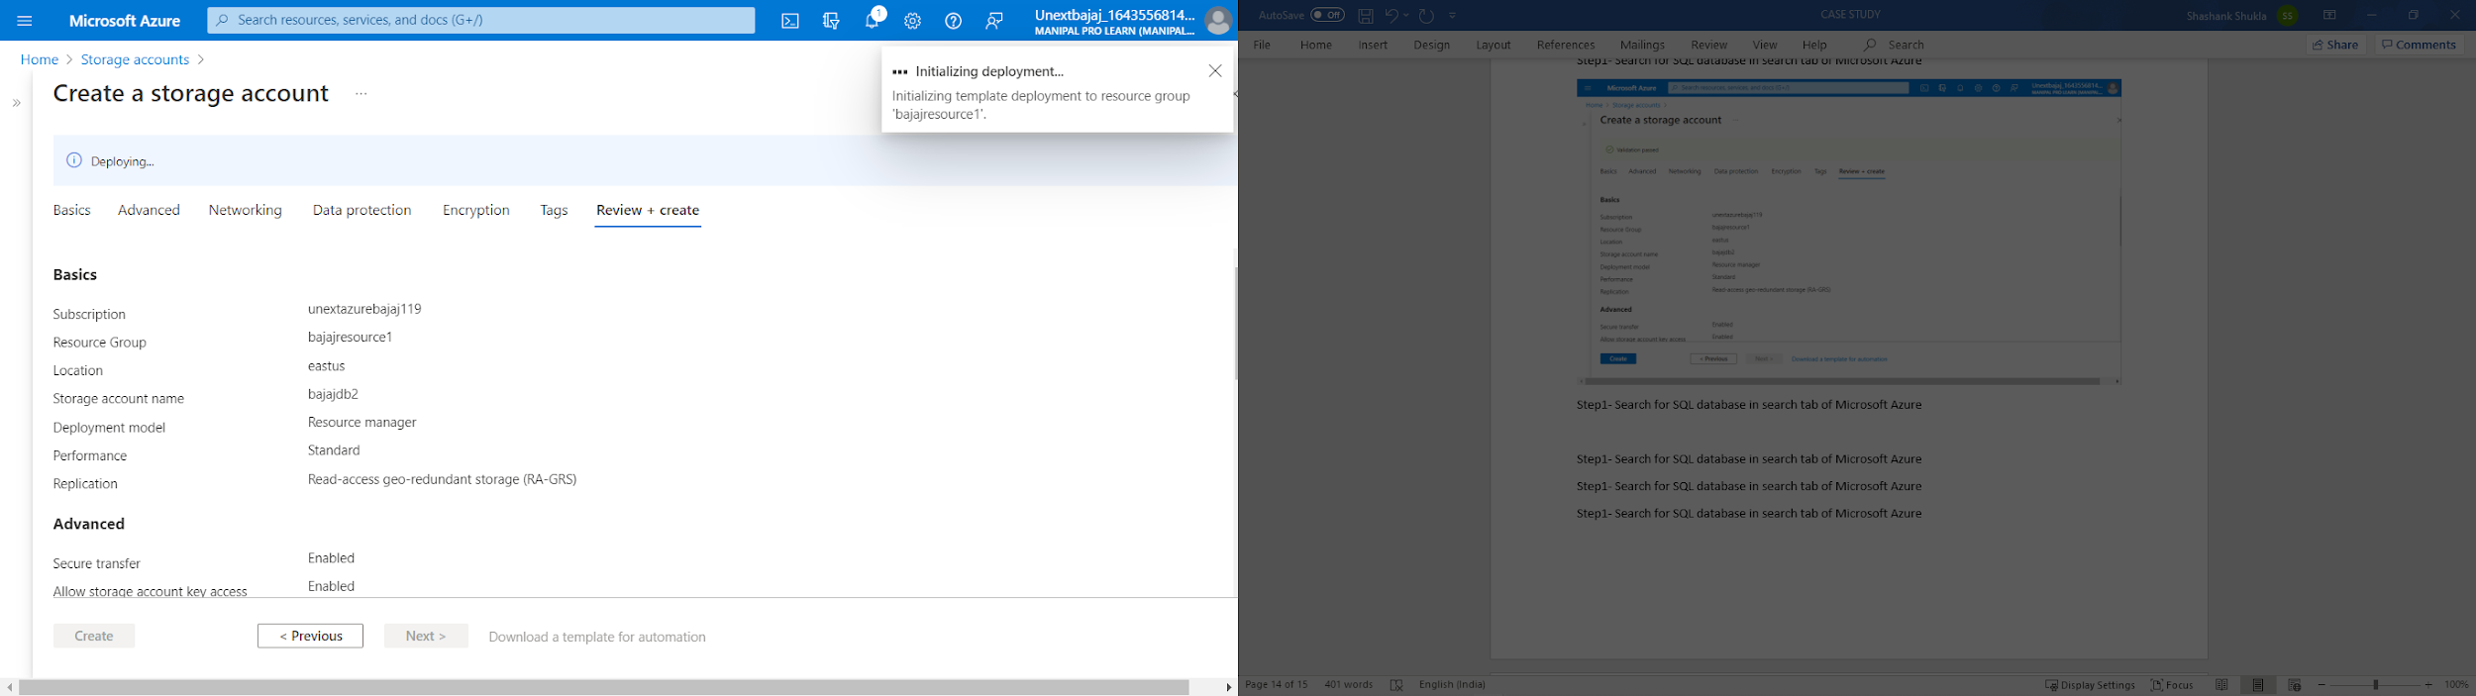

Step7- After deployment is complete, click on go to resources

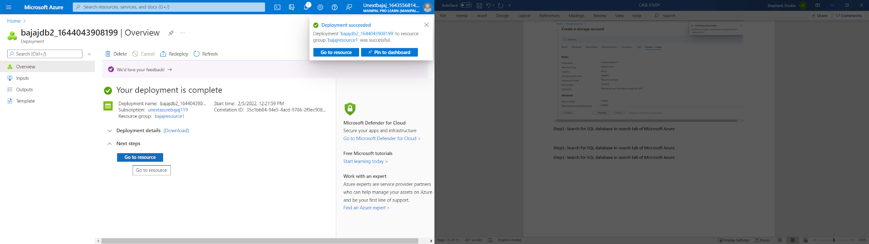

Step8- Click on Containers in the resource tab for Azure Blob Storage

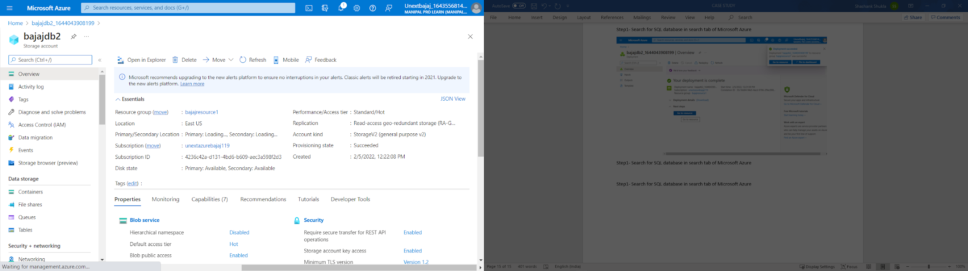

Step9- Click on + Container and add Name of the container

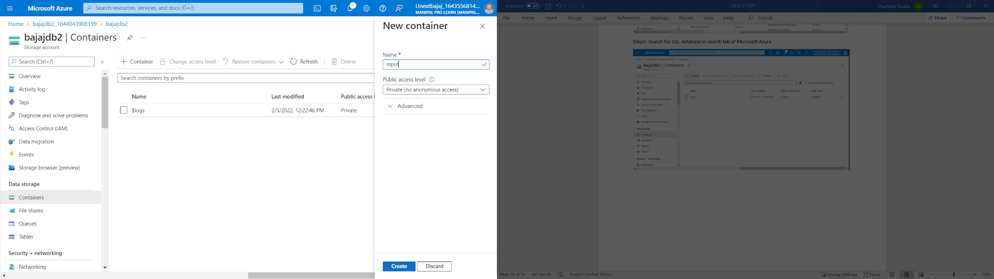

Step10- Similarly, create output folder

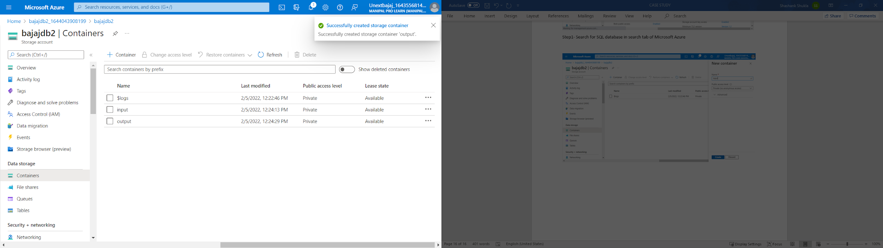

Step11- Upload a file by going into the input folder and click on upload

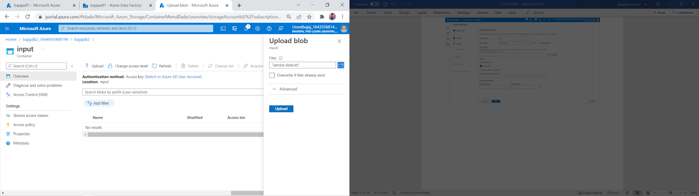

Step12-Upload a file in the upload section

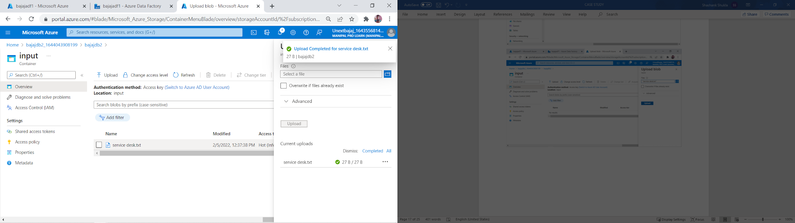

Step13- Search for data factory in the search tab

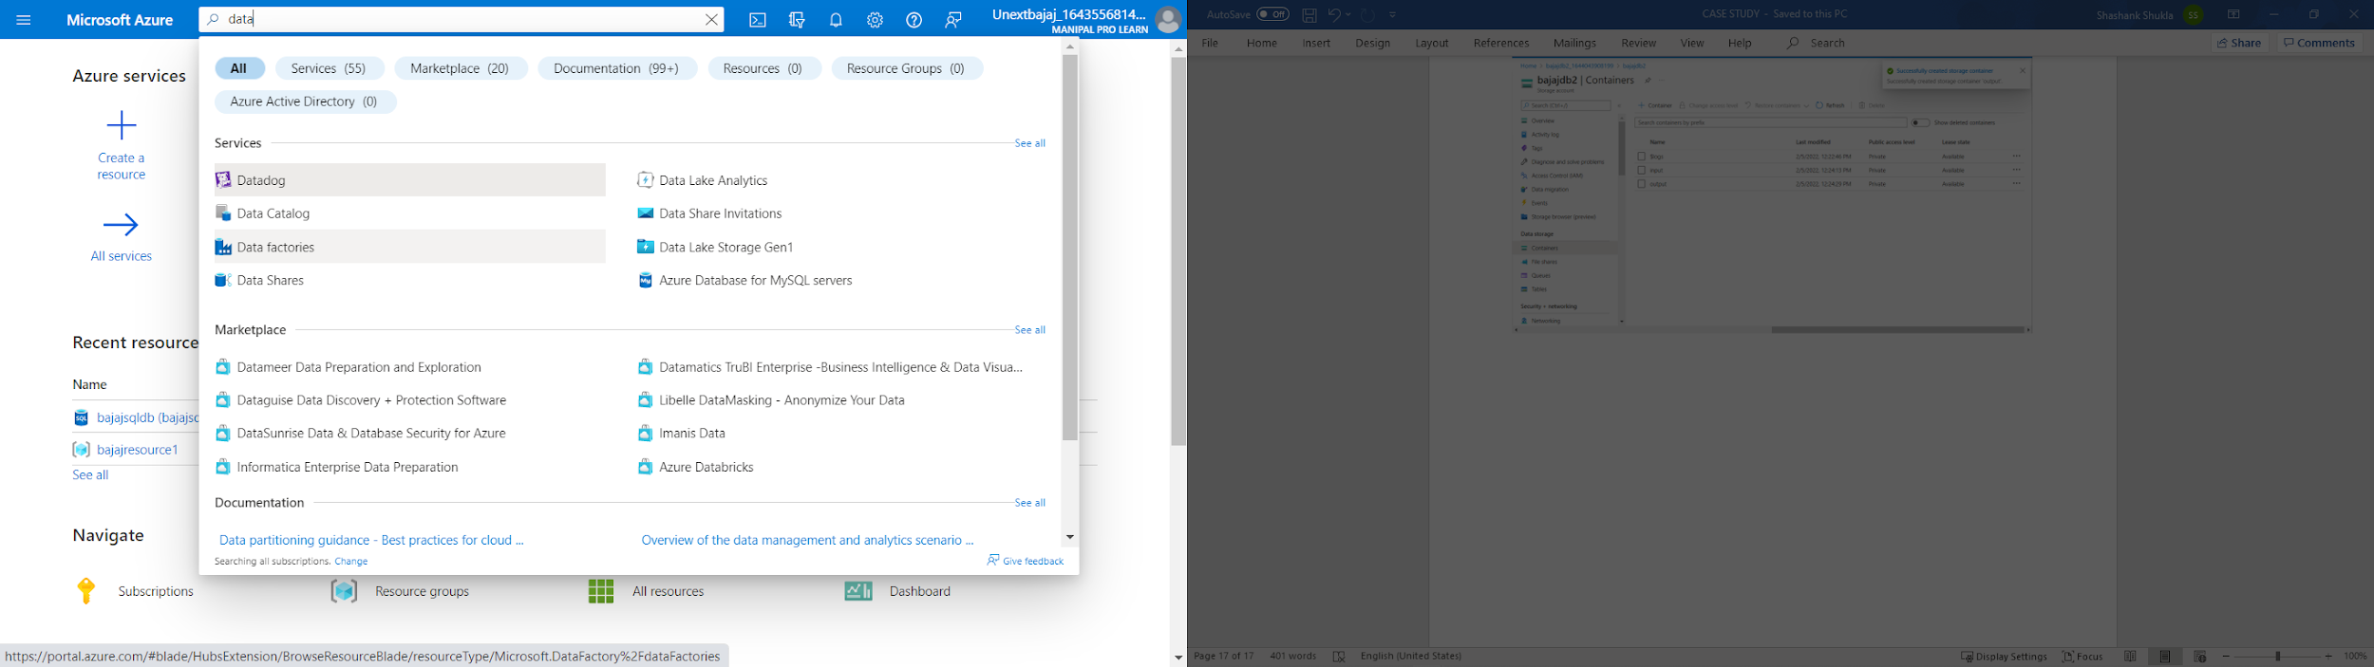

Step14- Click on Create in the Data factories tab

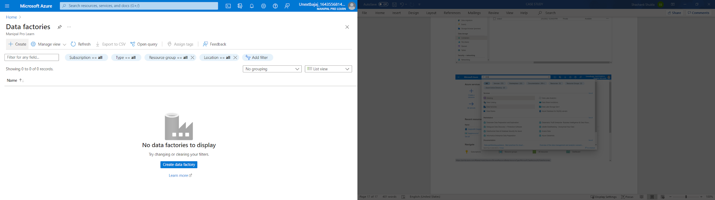

Step15- Enter a name for resource group or select form the existing ones   
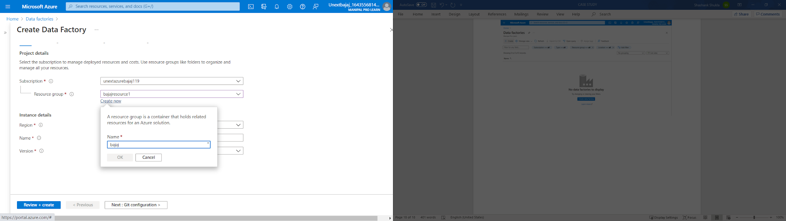

Step16- Enter the name of the data factory

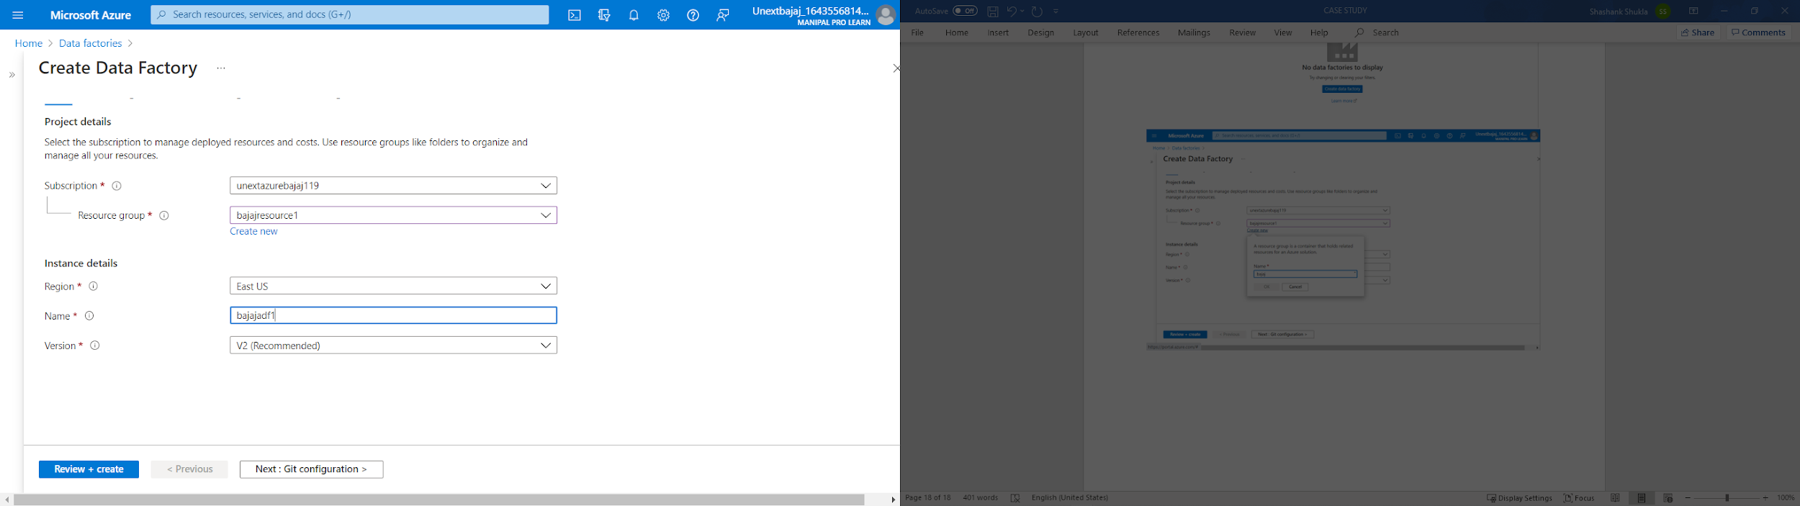

Step17- Click on Review +Create for validation and then Click on Create for deployment

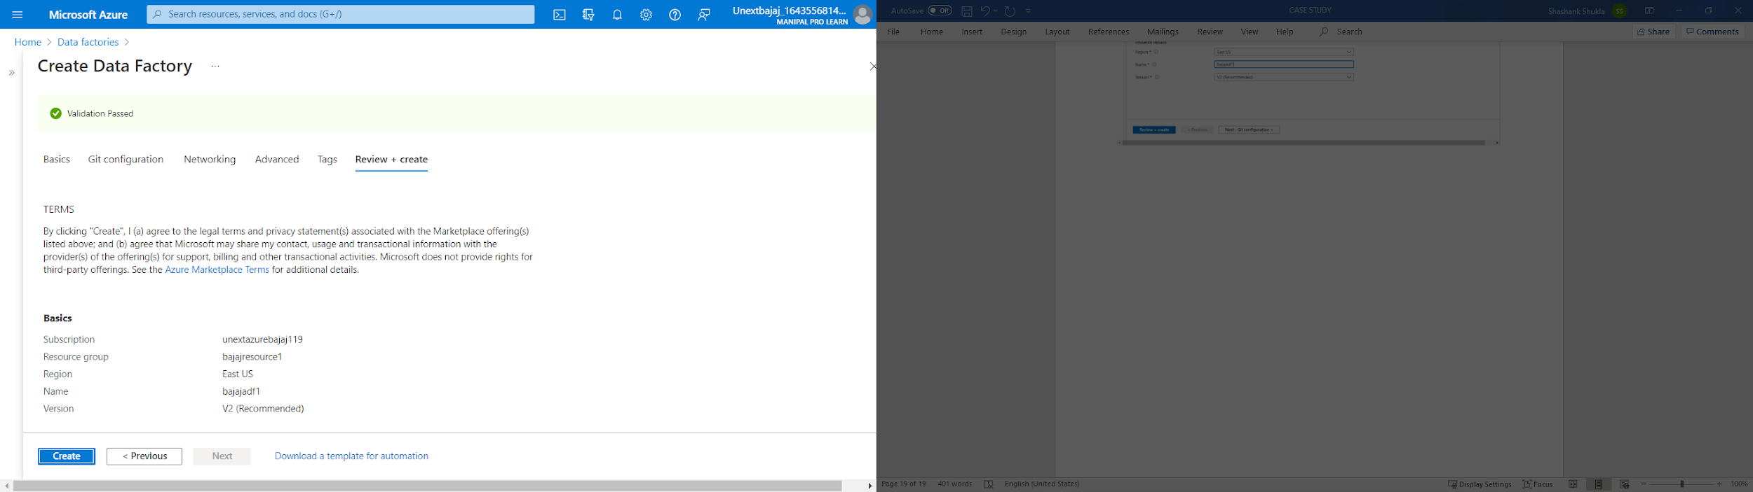

Step18- Once deployment is complete, click on go to resources

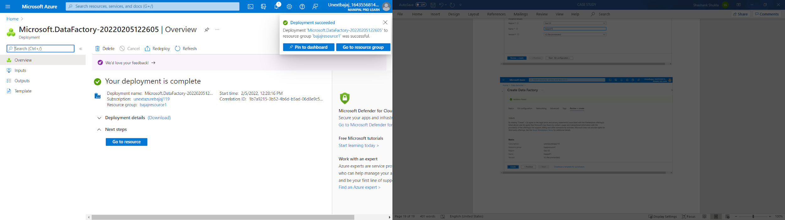

Step19- Click on Open in resource overview page

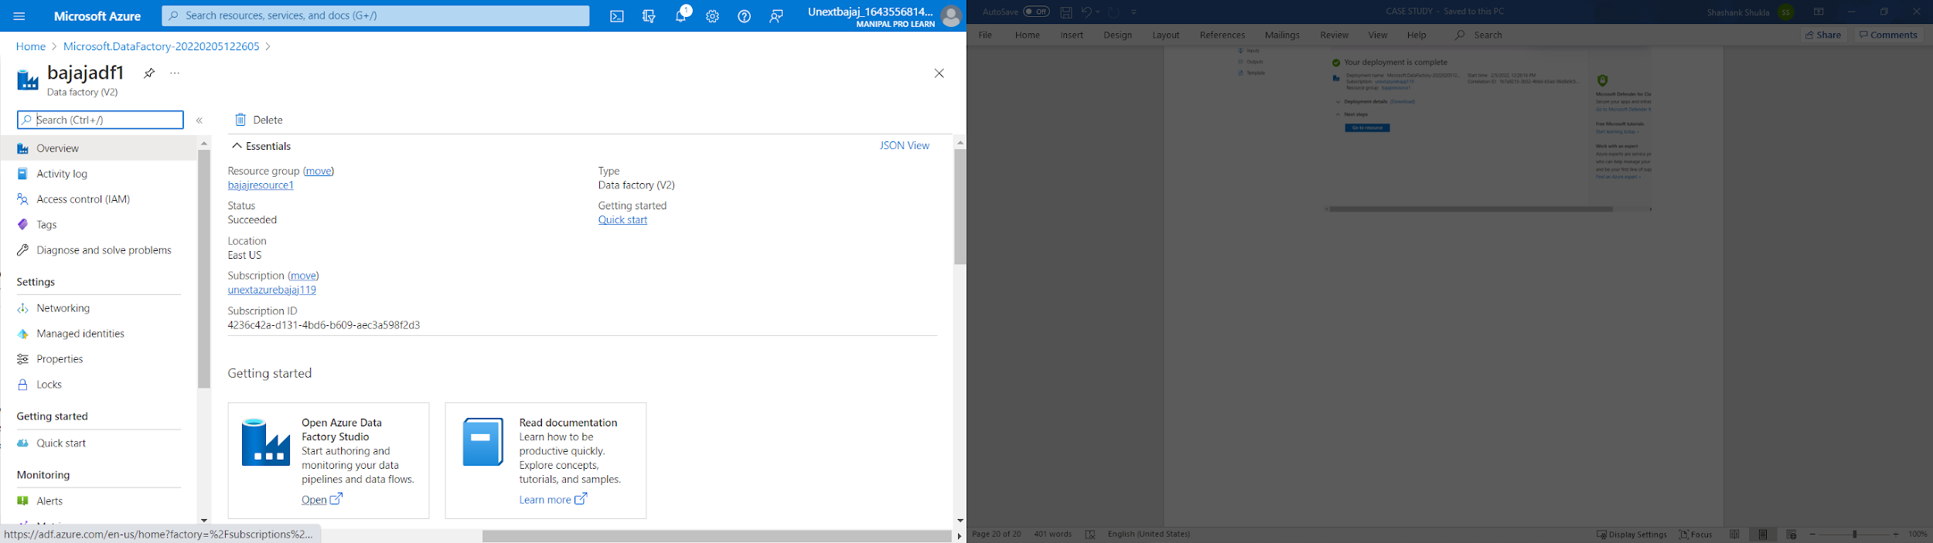

Step20- Select Ingest tab for movement of data in data factory page

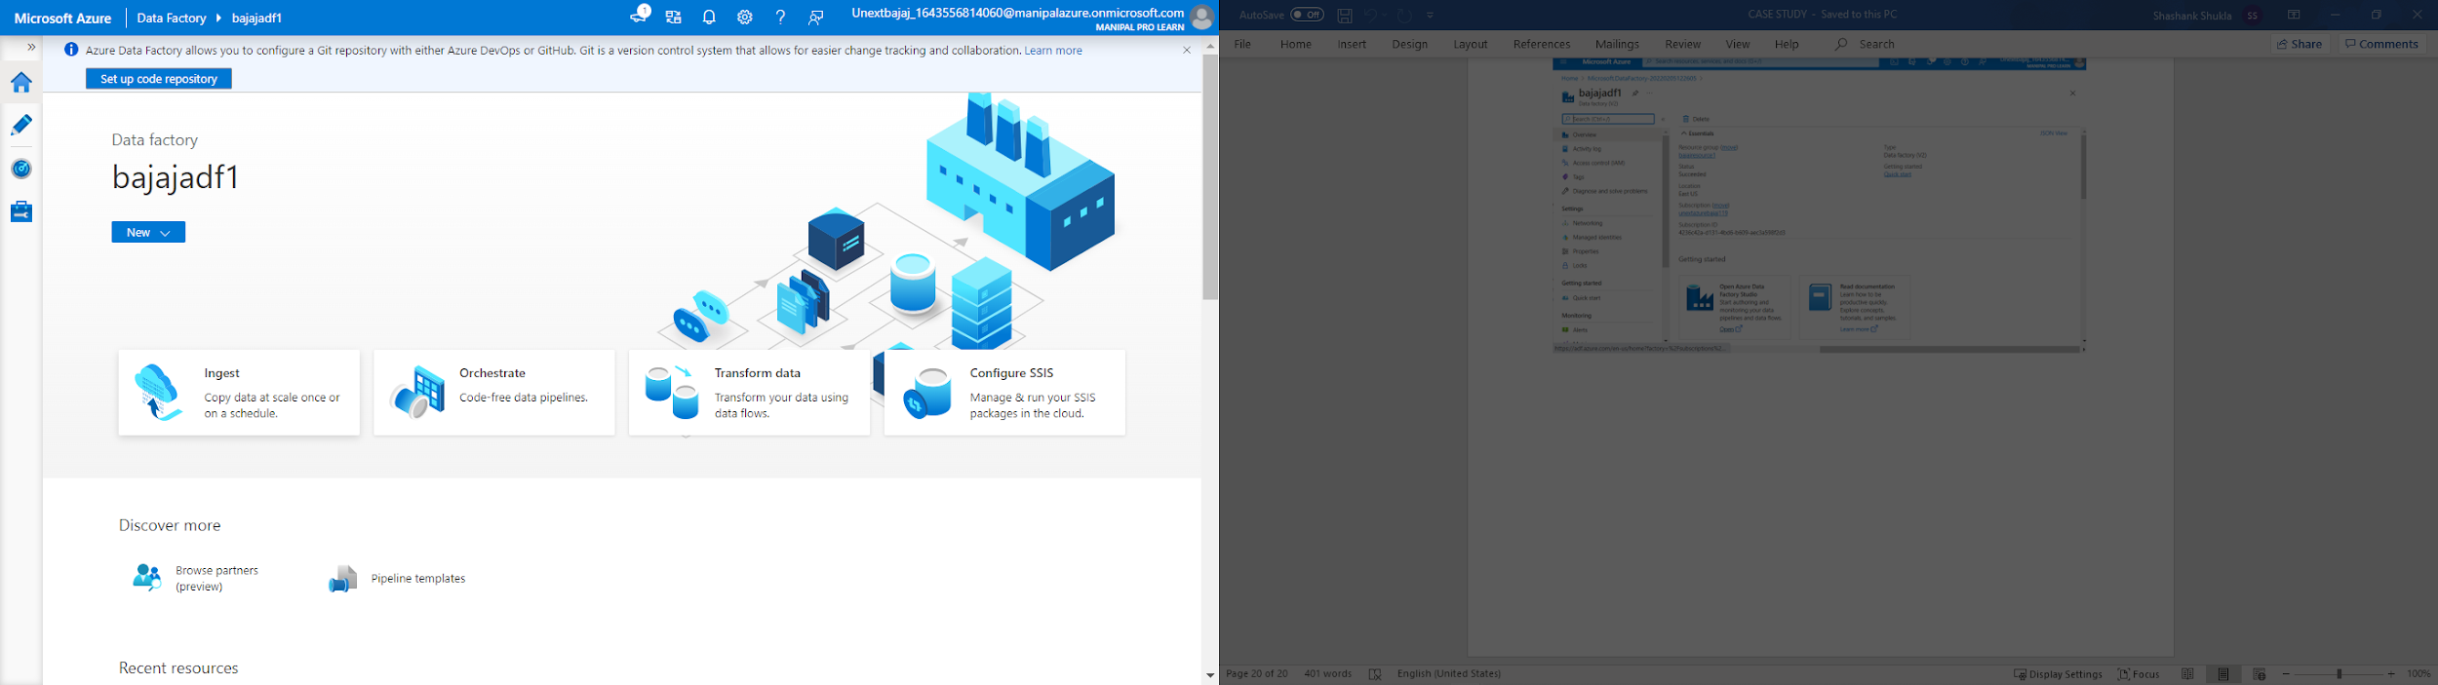

Step21- Select Run once now and click on next

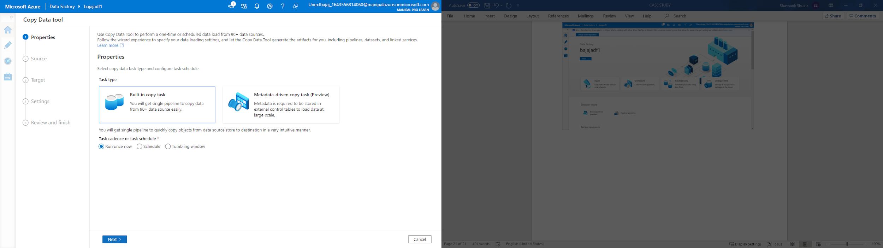

Step22- Click on create connection in source data store page

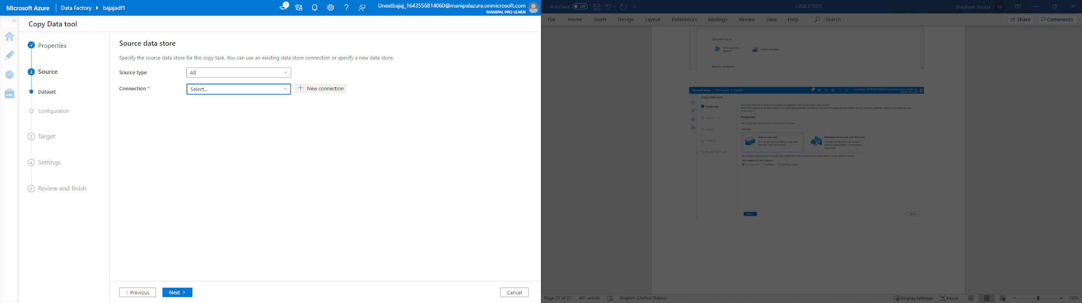

Step23- Select azure blob data storage from the pop up menu

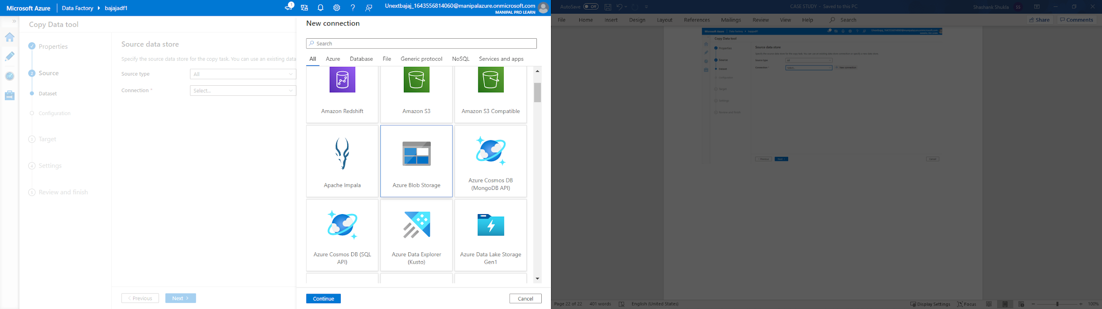

Step24- Enter name of connection, description and select azure subscription and storage name

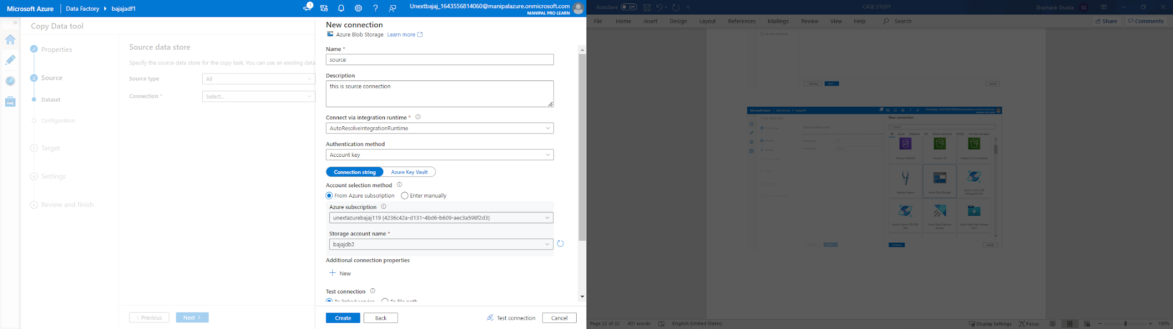

Step25- Click on test connection for testing the created connection

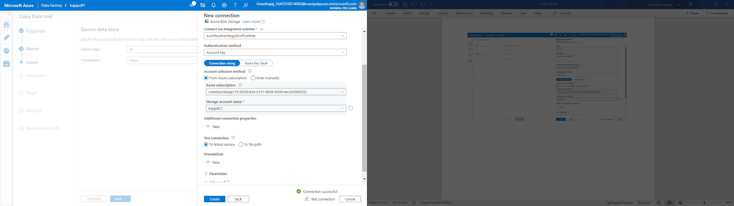

Step26- Click on browse in dataset page

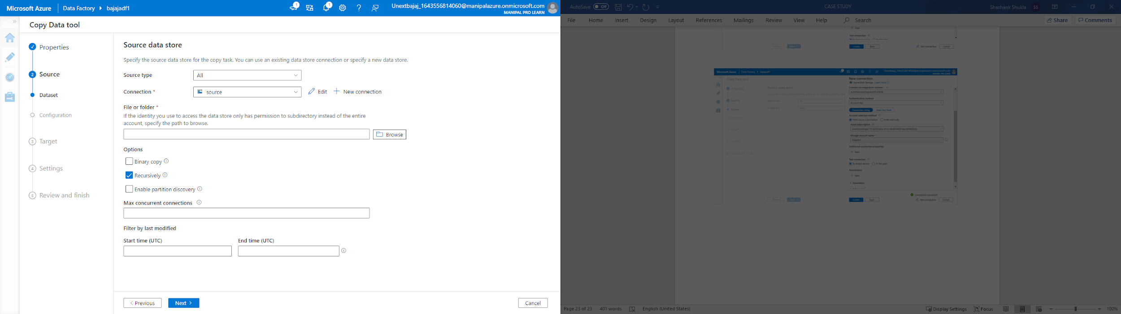

Step27- Browse the required file which have to be copied

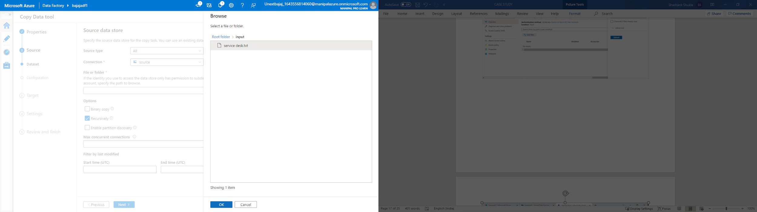

Step28- Click on preview to see the data and cross check

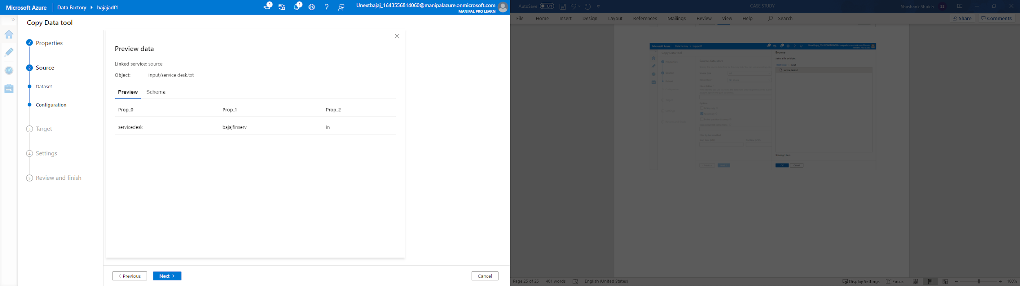

Step29- Select azure blob storage

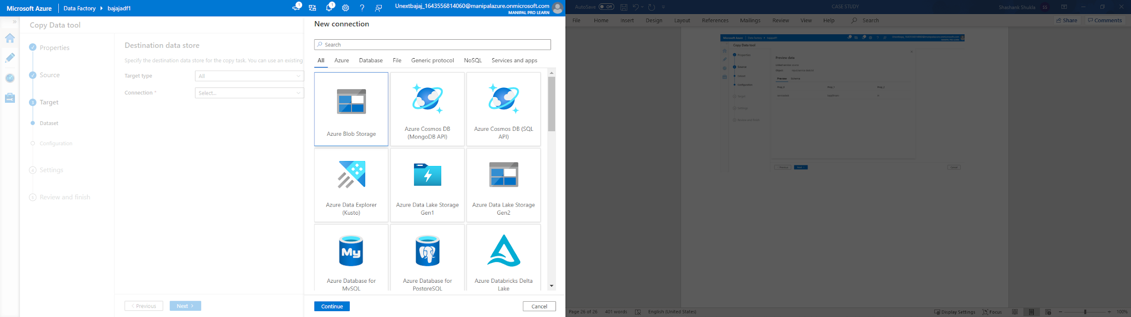

Step30- Select azure subscription, connection name, description and account name

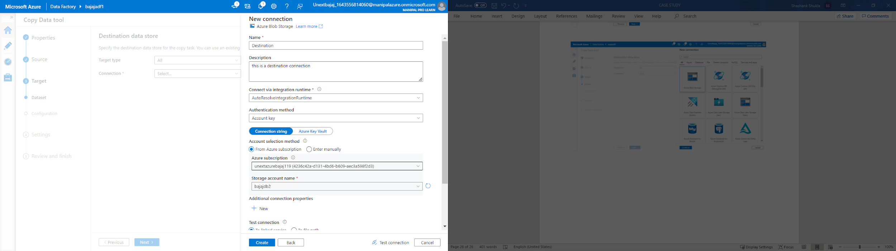

Step31- Click on test connection to test the conneciton

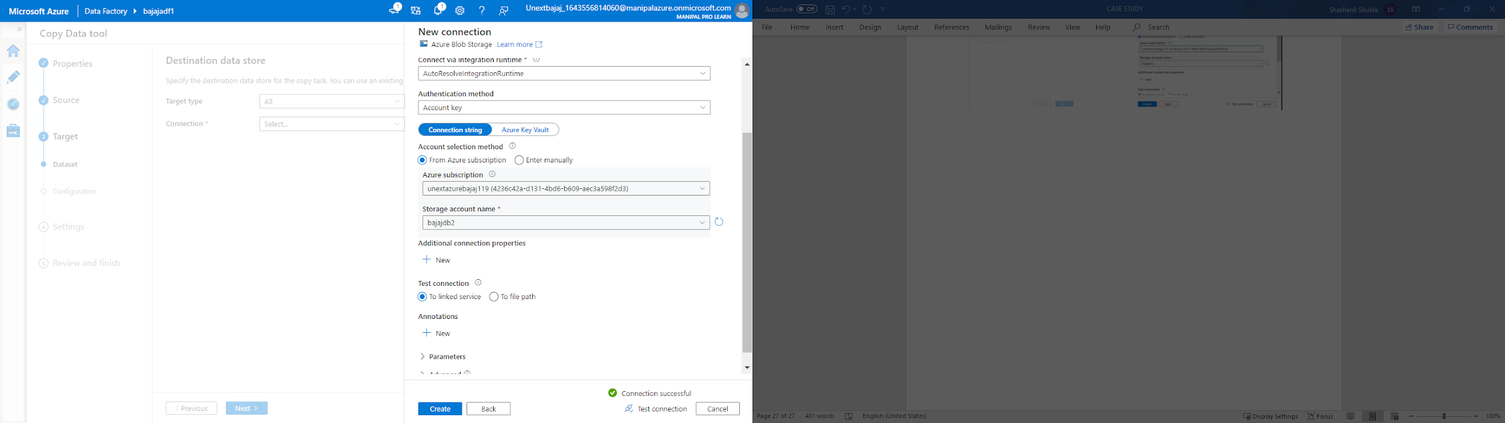

Step32- Click on browse to select the destination folder

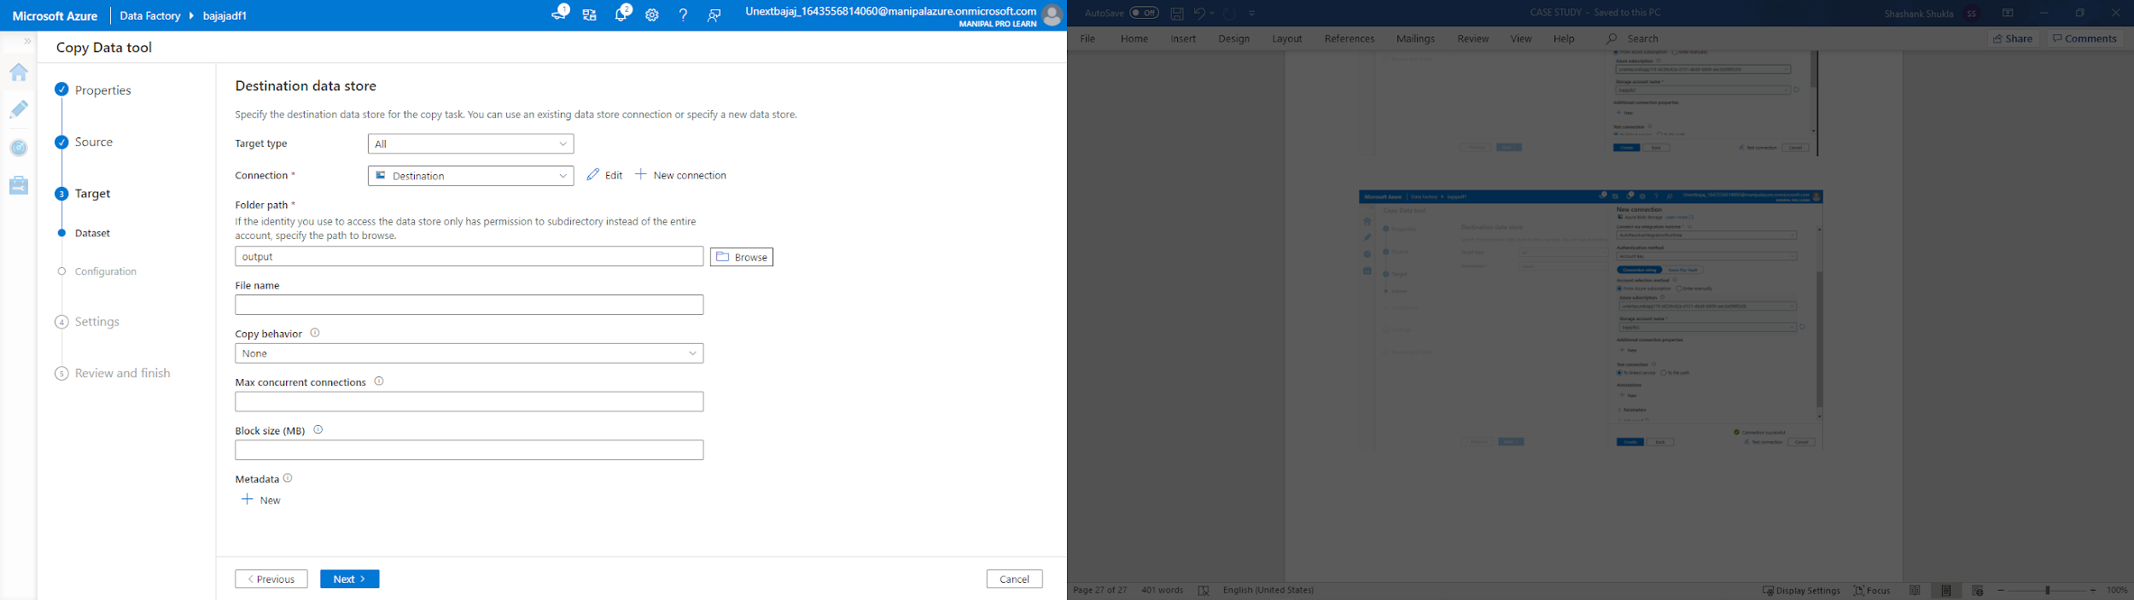

Step33- Check file format and select next

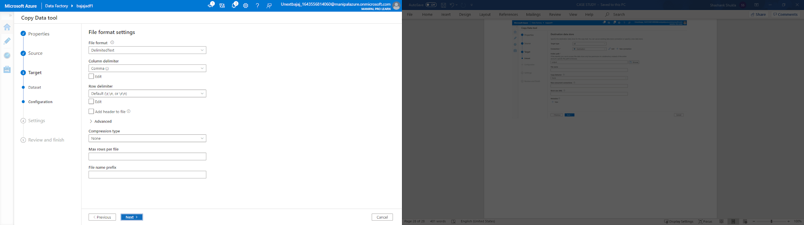

Step34- Check details and select next

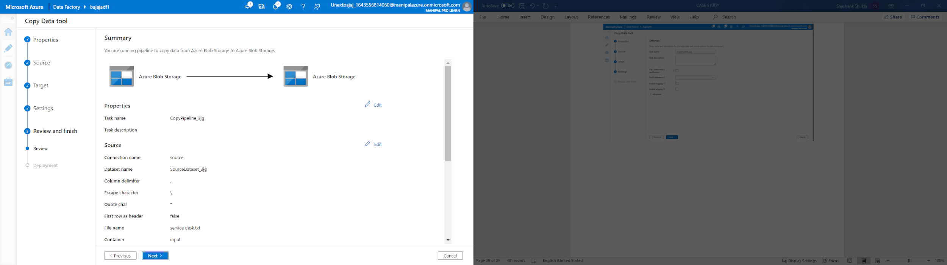

Step35- Once deployment is complete, select finish

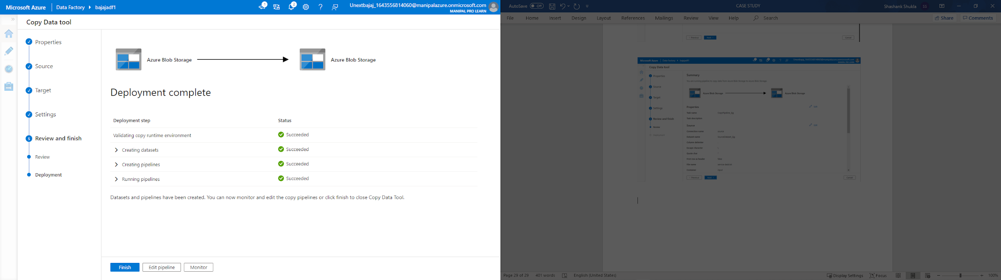

Step36- Check the copied file in destination folder of the storage account

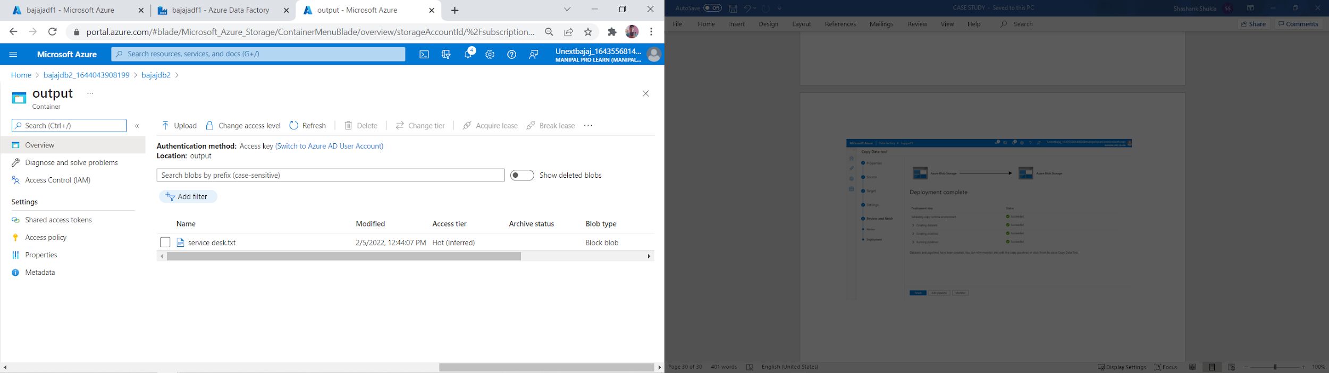

**Case- 10. In Azure, please create a Python app service & explain all the steps with screenshots?**

Step 1 - search for app service in search bar and open app service

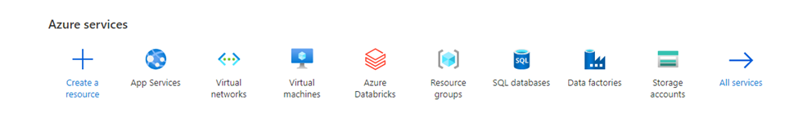

Step 2 – click on create then create a new resource group then give the name to the app and select the language in Run time stack

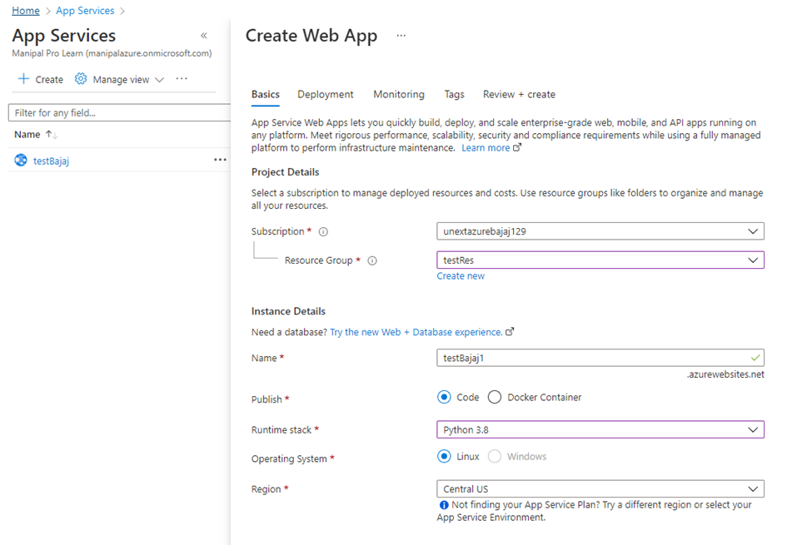

Step 3 – Click on review + create and then click on create after deployment is successful click on go to resource.

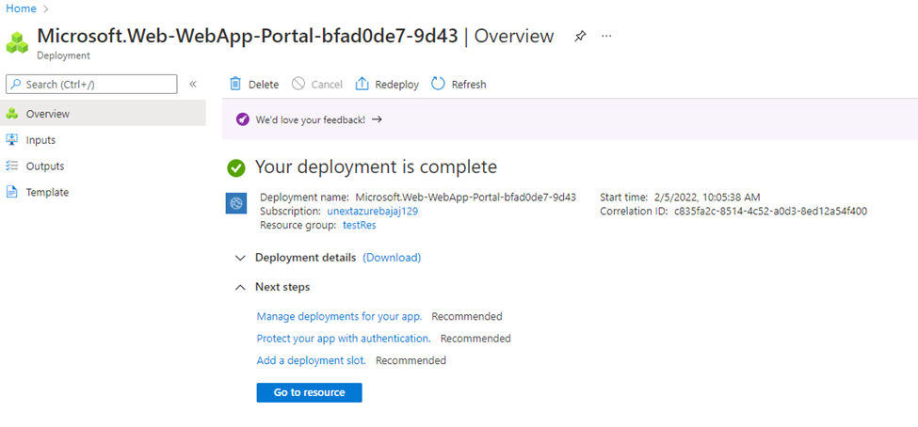

Step 4 click on deployment center

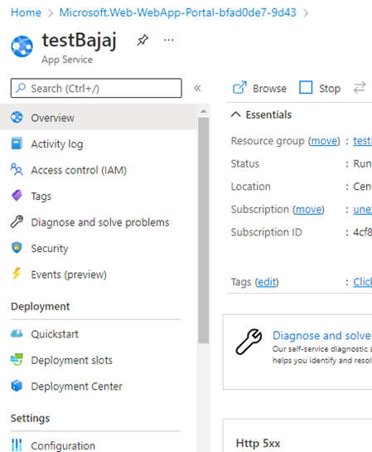

Step 5- click on source select GitHub or wherever the code is saved then sign in with GitHub, click on organization and select your acc name in repository select the repo you want to use and then branch and click on save

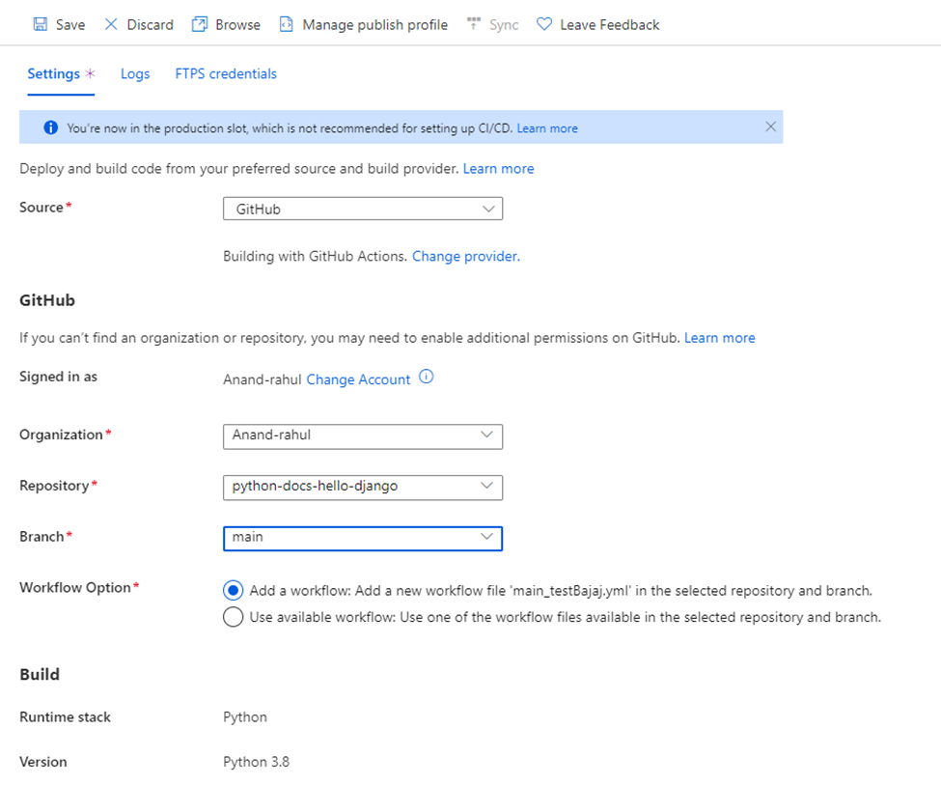

Step 6 click on logs and click on refresh

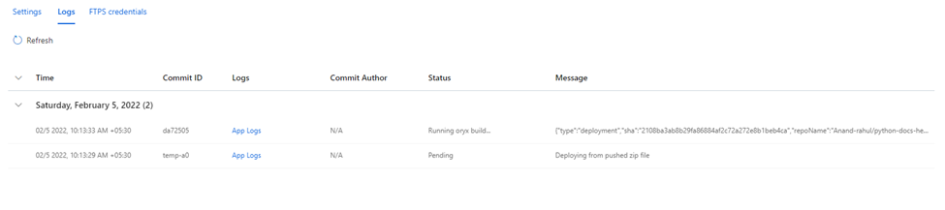

Step 7 once the status is active head back to overview page and open the URL in new tab

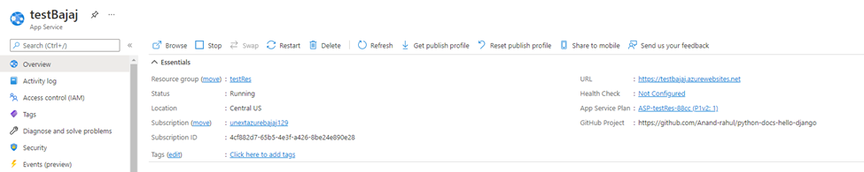

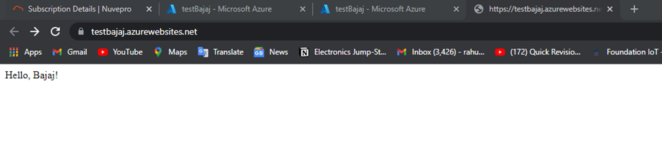

**Case 11. Please create Azure data bricks & explain all steps with screenshots**

1. In the Azure portal, select Create a resource > Analytics > Azure Databricks.
2. Under Azure Databricks Service, provide the values to create a Databricks workspace.

Provide the following values:

|  |  |
| --- | --- |
| **Property** | **Description** |
| Workspace name | Provide a name for your Databricks workspace |
| Subscription | From the drop-down, select your Azure subscription. |
| Resource group | Specify whether you want to create a new resource group or use an existing one. A resource group is a container that holds related resources for an Azure solution. |
| Location | Select West US 2. |
| Pricing Tier | Choose between Standard, Premium, or Trial. |

1. Select Review + Create, and then Create. The workspace creation takes a few minutes. During workspace creation, you can view the deployment status in Notifications. Once this process is finished, your user account is automatically added as an admin user in the workspace.

When a workspace deployment fails, the workspace is still created in a failed state. Delete the failed workspace and create a new workspace that resolves the deployment errors. When you delete the failed workspace, the managed resource group and any successfully deployed resources are also deleted.

**Case 12. In Azure data bricks - please add data & create table**

**(1) Using UI option**

**(2) create a table using the notebook option & explain all the steps.**

STEP 1: Once you sign in, to created data bricks account, you must first create a cluster

by selecting CREATE> CLUSTER option

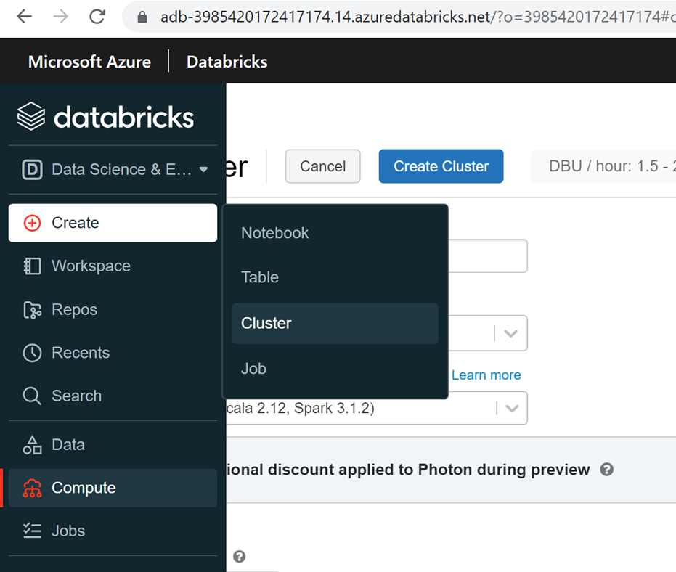

STEP 2: Enter details like cluster name and set no. of workers minimum to 1 and maximum to 2

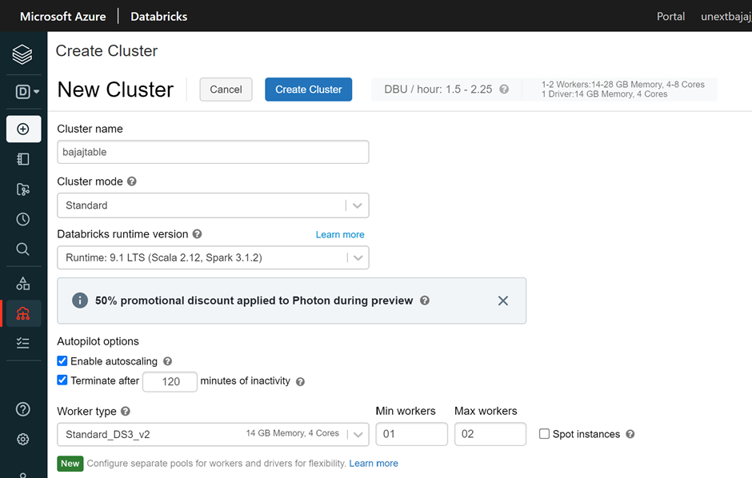

STEP 3: Now select create cluster

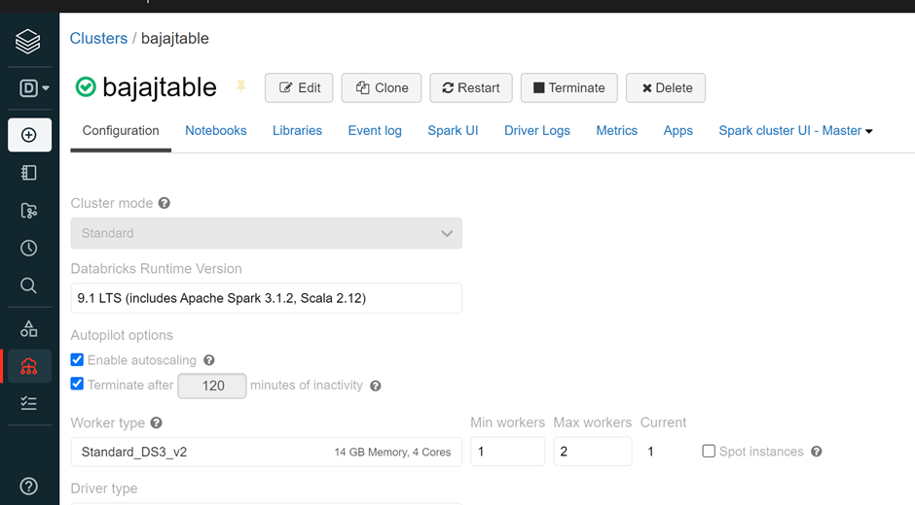

STEP 4: Once the cluster is created, we can create a table, by selecting CREATE>TABLE

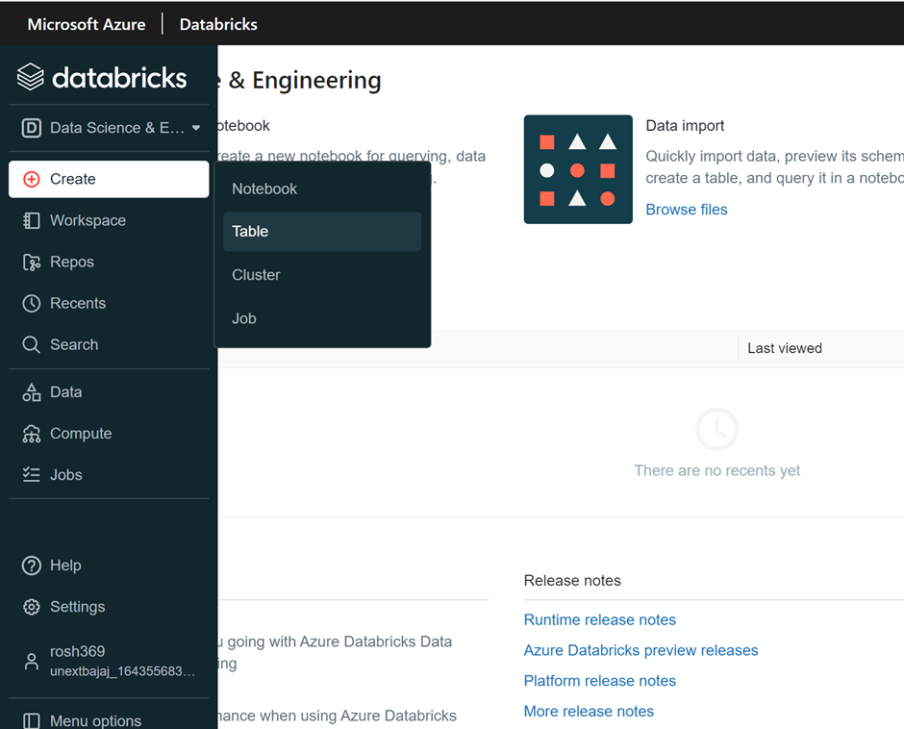

STEP 5: Upload a csv file from your system

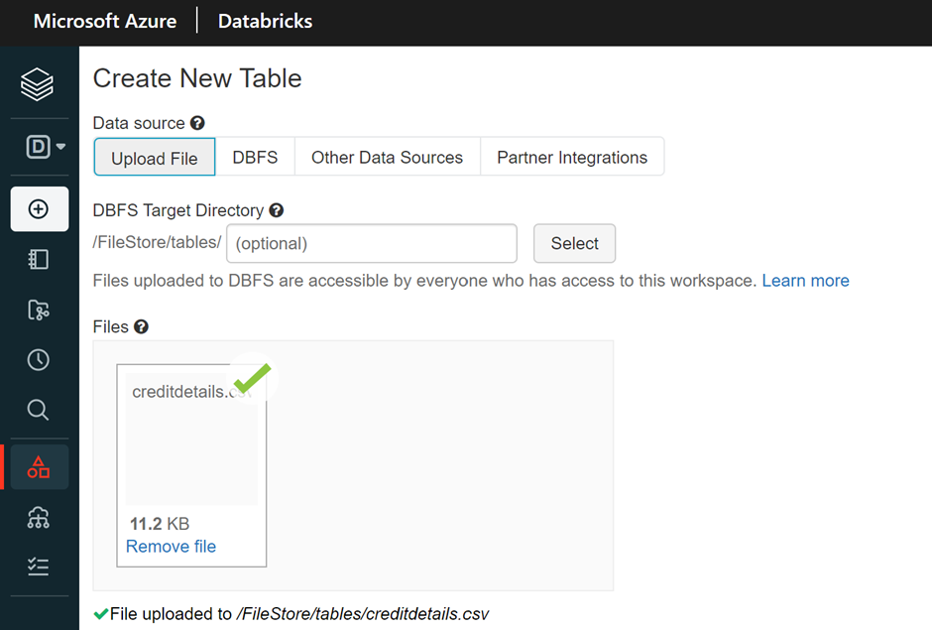

Step 6: For Creating table with UI, select the cluster and choose Create Table with UI option

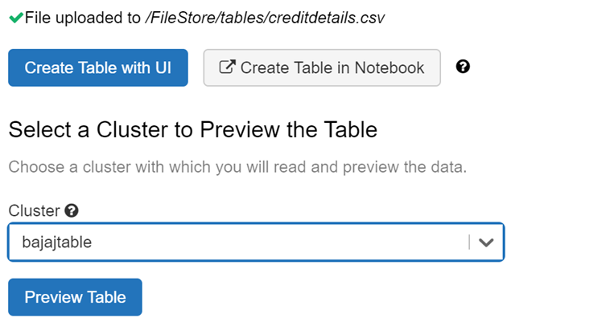

Step 7: Choose Preview table to look at the table uploaded

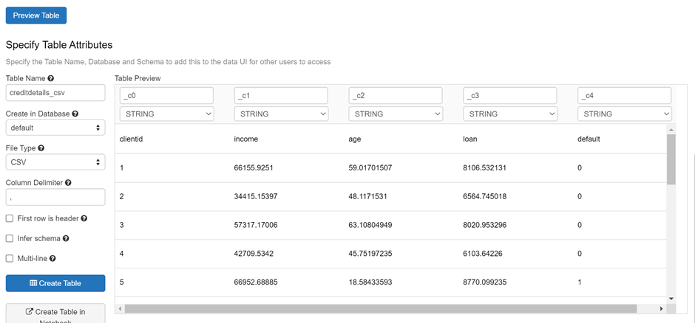

Now, to create table using notebook option

Select create table with notebook option> attach the cluster created

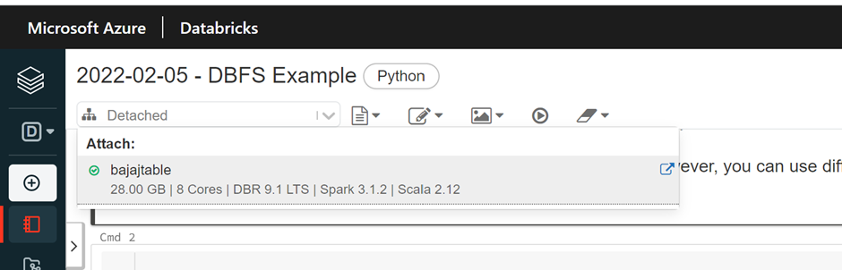

Run the first command to preview the table

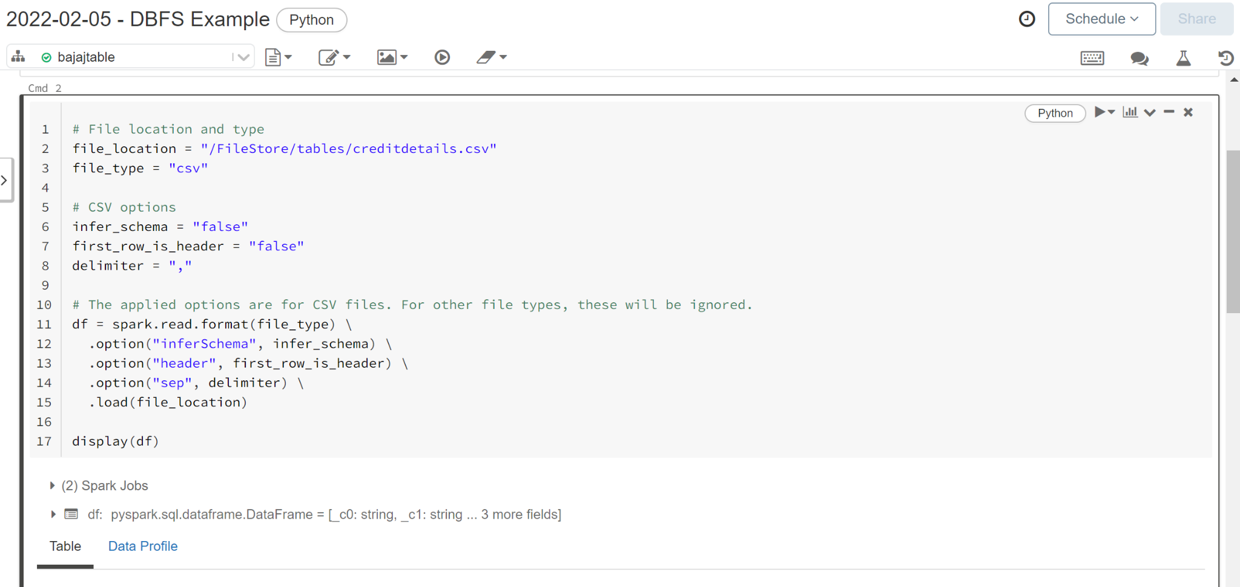

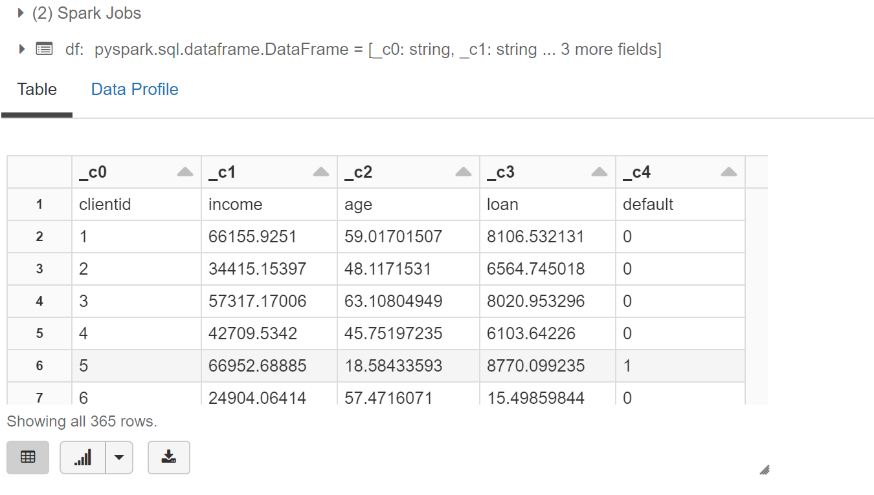

**Case 13. In Azure data bricks - please create Cluster & explain with all steps with screenshots?**

Solution:

Step 1 – After opening azure data bricks workspace click on create then on cluster

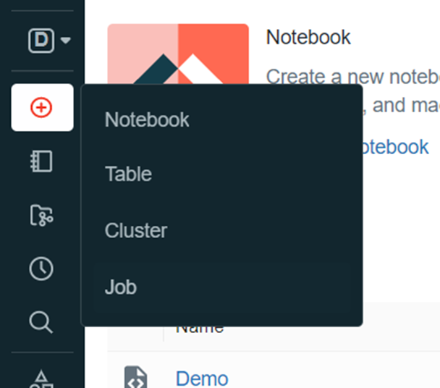

Step 2 – a new window opens give the cluster name , cluster mode can be standard or single mode according to usage , change the min workers to 1 and max workers to 2 , hit create cluster

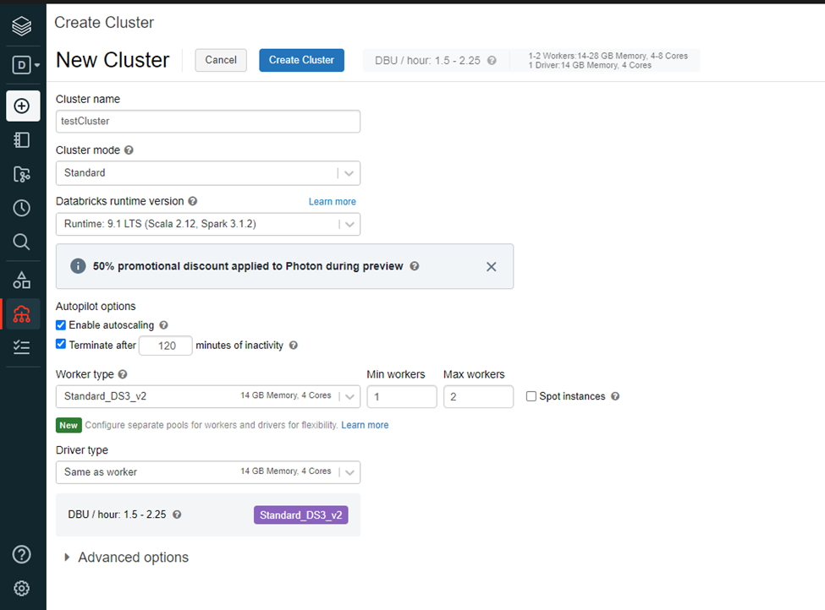

Step 3 cluster is being created

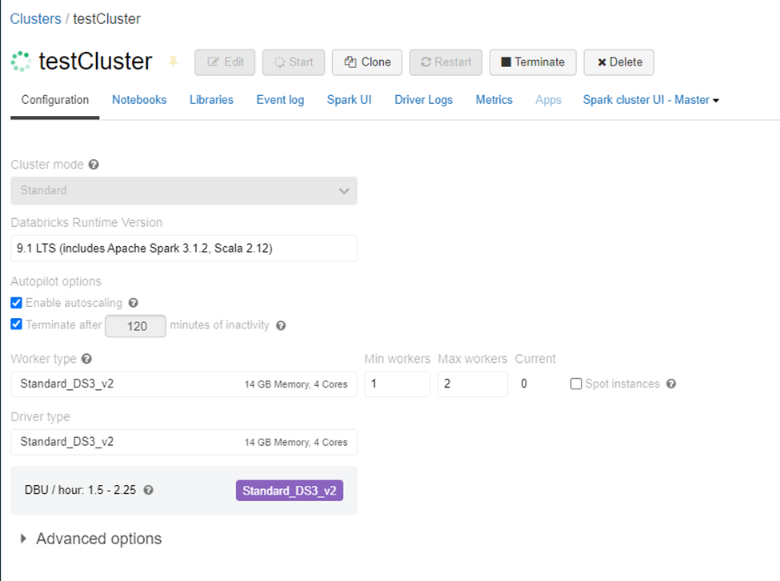

Step 4 click on compute from left menu bar

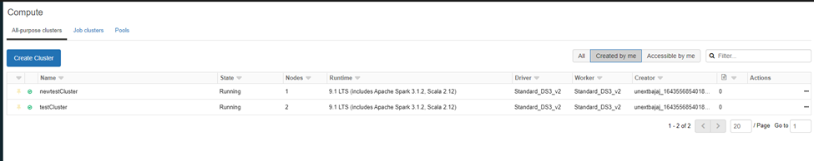

These are the created Clusters

**Case 14. In Azure data bricks - please create sample Notebook & jobs , further assign sample notebook to jobs & run it, explain with all steps with screenshots ?**

Solution-

Step 1: click on azure data bricks

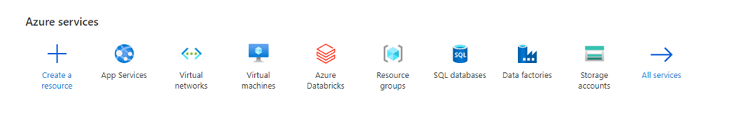

Step 2 click on create , select the resource group and provide the name for workspace

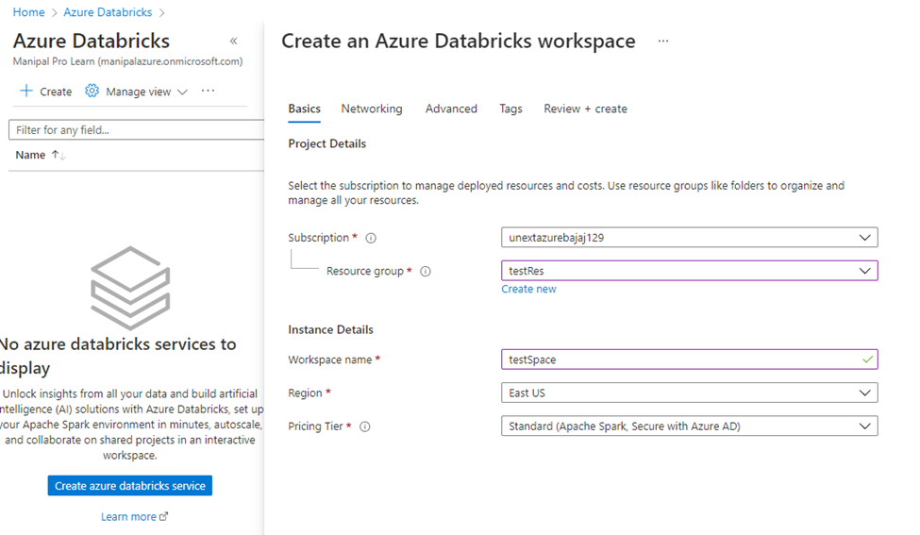

Step 3 click on review +create and then click on create after validation succeeded.

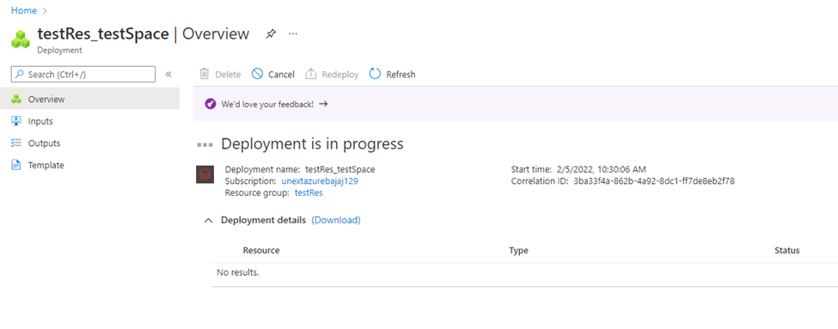

Step 4 – once the deployment is complete click on go to resource then click on launch . Explain various features of python & advantages of it over other programming languages ?

workspace

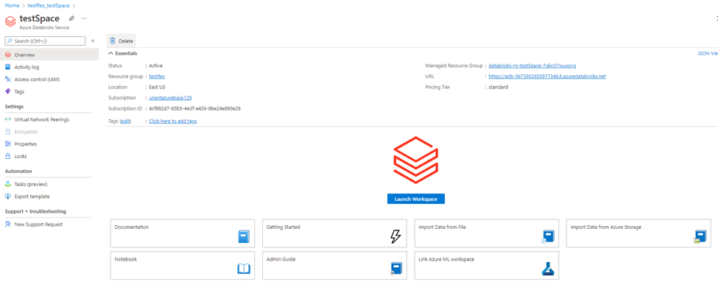

Step 5 – click on workspace, in the dropdown click on create and again in the dropdown click on folder to create a new folder

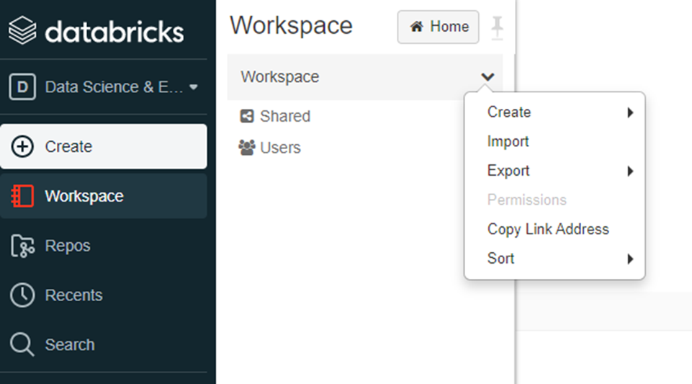

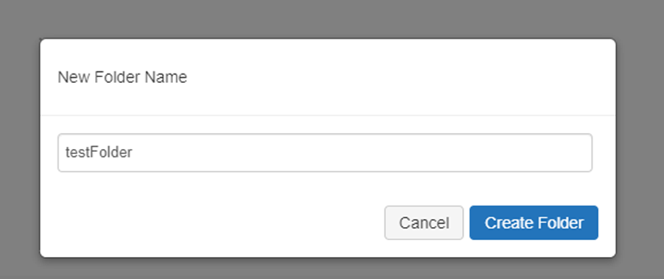

Step 6- once the folder is created click on its dropdown and click on import to import a notebook from local system and import the file from the local system

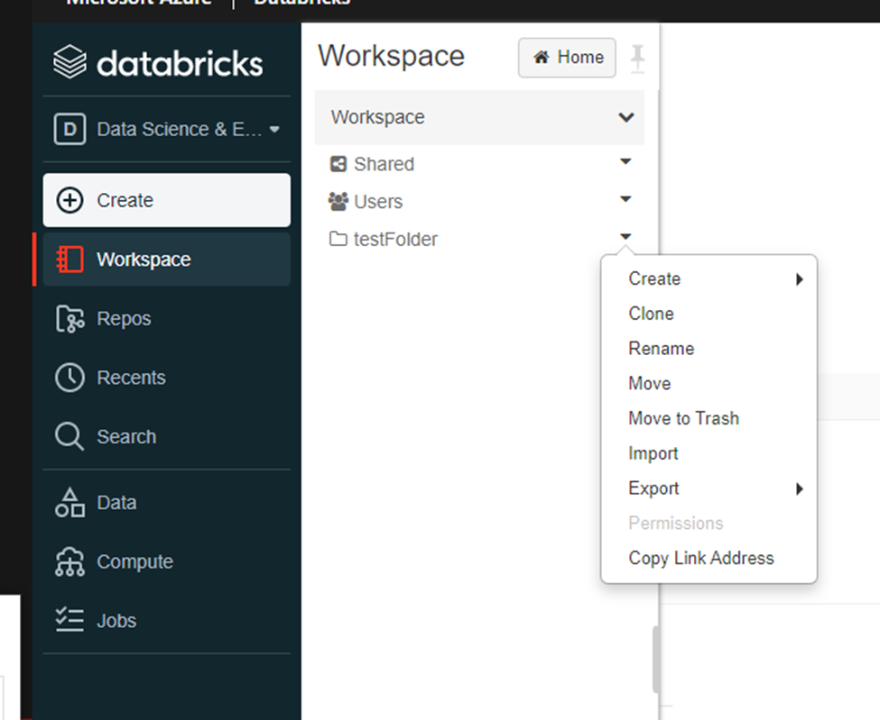

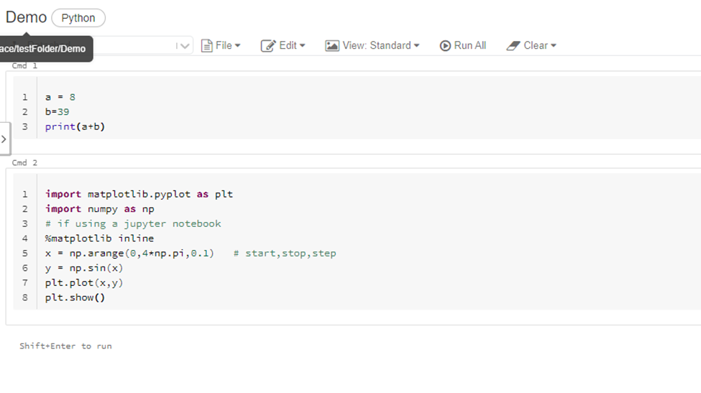

Step 7 click on create and then click on job , give the name of the job and select the notebook imported earlier click on create

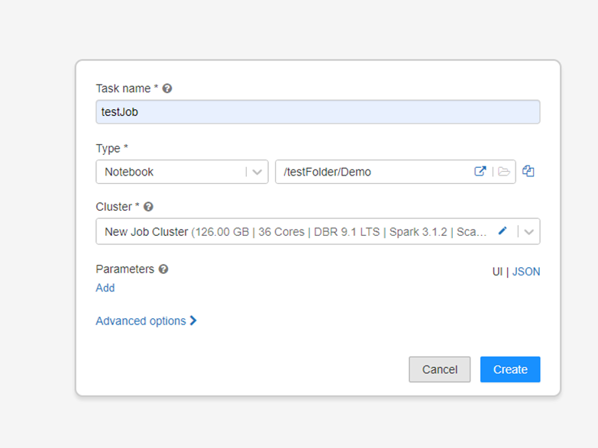

Step 8 -once the job is created click on edit schedule in right hand side menu , the in the new popup click on schedule and then in schedule below click on minute

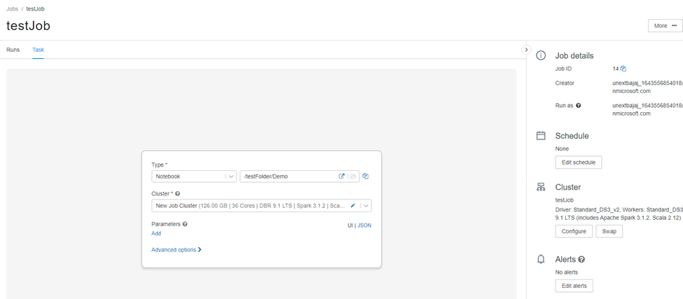

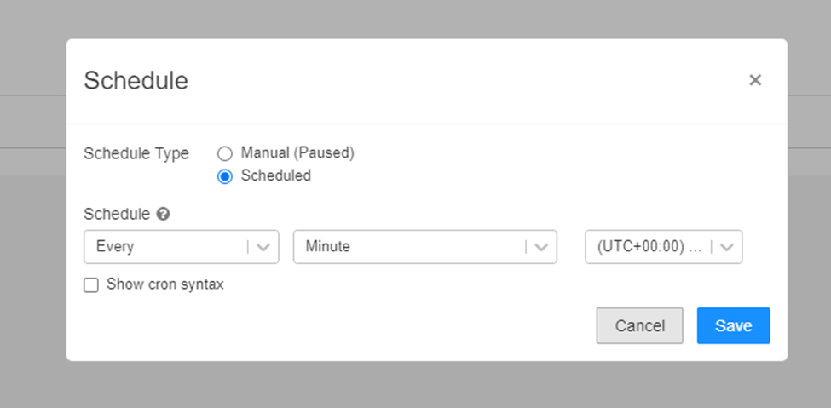

Step9 – click on runs then click on refresh and wait for the job to be launched by scheduler

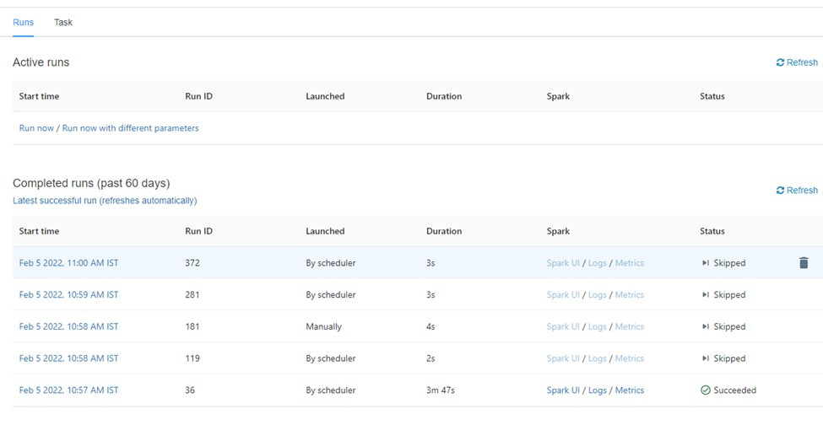

**Case 15- Explain various features of python & advantages of it over other programming languages?**

Python is a powerful, high-quality, free open source and editing programming language. Supports object-focused programs and process-focused programs.

In Python, there is no need to declare a variation because it is a dynamic typed language.

For example, x = 10

Here, x can be anything like String, int, etc.

Features in Python

There are many features in Python, some of which are discussed below -

1. Easy to enter code:

Python is an advanced programming language. Python is much easier to learn a language compared to other languages ​​such as C, C #, Javascript, Java, etc. It is very easy to write code in python language and anyone can learn the basics of python in hours or days. And it is the right language for the engineer.

2. Free and open source:

Python Language is available for free on the official website and you can download from the provided download link below click the Python Download Keyword.

Download Python

Being an open source, this means that the source code is also publicly available. So you can download it as, use it and share it.

3. Focused Language:

One of the most important features of python is the Object-Oriented system. Python supports object-oriented language and class concepts, object encapsulation, etc.

4. GUI Programming Support:

Graphical User interfaces can be created using modules such as PyQt5, PyQt4, wxPython, or Tk in python.

PyQt5 is a very popular way to create animated applications with Python.

5. Advanced Language:

Python is an advanced language. When writing programs in python, we do not need to remember system configurations, nor do we need to manage memory.

6. Expandable feature:

Python is an Extensible Language. We can write the Python code in C or C ++ and compose that code in the C / C ++ language.

7. Python portable language:

Python language is also a tangible language. For example, if we have a python code for windows and if we want to use this code on other platforms like Linux, Unix, and Mac we do not need to change it, we can use this code on any platform.

8. Python Integrated Language:

Python is also an Integrated language because we can easily integrate frames with other languages ​​such as c, c ++, etc.

9. Translated Language:

Python is a Translated Language because Python code is used line by line at a time. like other languages ​​C, C ++, Java, etc. no need to compile python code this makes it easy to fix our error. Python source code is converted into a fast form called bytecode.

10. Large General Library

Python has a large standard library that provides a rich set of modules and functions so you do not have to write your code for everything. There are many libraries available in python such as standard expressions, unit tests, web browsers, etc.

Advantages

1. Translated Language

Python is a translated language which means that Python directly uses linear code. In the event of an error, it stops proceeding and reports the error that occurred.

Python only shows one error even though the system has many errors. This makes debugging easier.

2. Type Tightly

Python does not know the type of variation until we run the code. It automatically provides the type of data during the execution. The editor does not have to worry about dynamic ads and their data types.

3. Free and open source

Python comes under OSI licensed open source license. This makes it free to use and distribute. You can download the source code, modify it and distribute your Python version. This is useful for organizations that want to change certain behaviors and use their own version to improve it.

4. Main Library Support

The standard Python Library is large, you can find almost every job needed for your job. Therefore, you do not have to rely on external libraries.

But even if you do, the Python (Pip) package manager makes it easy to import other great packages from the Python package (PyPi) directory. Contains more than 200,000 packages.

5. Portability

In most languages ​​like C / C ++, you need to change your code to launch the program in different forums. That's not the same as Python. You write only once and use it anywhere.

However, you should be careful not to include system-dependent features.